UNIT – I
Chapter 1
Introduction

  - DATA COMMUNICATIONS

Data communications are the exchange of data between two devices via some form of transmission medium such as a wire cable. For data communications to occur, the communicating devices must be part of a communication system made up of a combination of hardware (physical equipment) and software (programs). The effectiveness of a data communications system depends on four fundamental characteristics: delivery, accuracy, timeliness, and jitter.

1. Delivery. The system must deliver data to the correct destination. Data must be received by the intended device or user and only by that device or user.
2. Accuracy. The system must deliver the data accurately. Data that have been altered in transmission and left uncorrected are unusable.
3. Timeliness. The system must deliver data in a timely manner. Data delivered late are useless. In the case of video and audio, timely delivery means delivering data as they are produced, in the same order that they are produced, and without significant delay. This kind of delivery is called real-time transmission.
4. Jitter. Jitter refers to the variation in the packet arrival time. It is the uneven delay in the delivery of audio or video packets. For example, let us assume that video packets are sent every 30 ms. If some of the packets arrive with 30-ms delay and others with 40-ms delay, an uneven quality in the video is the result.

Components

A data communications system has five components:
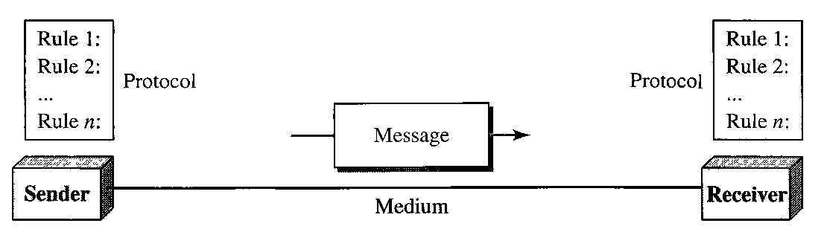

1. Message. The message is the information (data) to be communicated. Popular forms of information include text, numbers, pictures, audio, and video.
2. Sender. The sender is the device that sends the data message. It can be a computer, workstation, telephone handset, video camera, and so on.
3. Receiver. The receiver is the device that receives the message. It can be a computer, workstation, telephone handset, television, and so on.
4. Transmission medium. The transmission medium is the physical path by which a message travels from sender to receiver. Some examples of transmission media include twisted-pair wire, coaxial cable, fiber-optic cable, and radio waves.
5. Protocol. A protocol is a set of rules that govern data communications. It represents an agreement between the communicating devices. Without a protocol, two devices may be connected but not communicating.

Data Representation

Information today comes in different forms such as text, numbers, images, audio, and
video.

Text
In data communications, text is represented as a bit pattern, a sequence of bits (0s or 1s). Different sets of bit patterns have been designed to represent text symbols. Each set is called a code, and the process of representing symbols is called coding. Today, the prevalent coding system is called Unicode, which uses 32 bits to represent a symbol or character used in any language in the world.

Numbers
Numbers are also represented by bit patterns. However, a code such as ASCII is not used to represent numbers; the number is directly converted to a binary number to simplify mathematical operations.

Images
Images are also represented by bit patterns. In its simplest form, an image is composed of a matrix of pixels (picture elements), where each pixel is a small dot. The size of the pixel depends on the resolution. For example, an image can be divided into 1000 pixels or 10,000 pixels. In the second case, there is a better representation of the image (better resolution), but more memory is needed to store the image.
After an image is divided into pixels, each pixel is assigned a bit pattern. The size and the value of the pattern depend on the image. For an image made of only black- and-white dots (e.g., a chessboard), a 1-bit pattern is enough to represent a pixel.
There are several methods to represent color images. One method is called RGB, so called because each color is made of a combination of three primary colors: red, green, and blue.

Audio
Audio refers to the recording or broadcasting of sound or music. Audio is by nature different from text, numbers, or images. It is continuous, not discrete. Even when we use a microphone to change voice or music to an electric signal, we create a continuous signal.

Video
Video refers to the recording or broadcasting of a picture or movie. Video can either be produced as a continuous entity (e.g., by a TV camera), or it can be a combination of images, each a discrete entity, arranged to convey the idea of motion.

Data Flow

Communication between two devices can be simplex, half-duplex, or full-duplex as shown in figure.
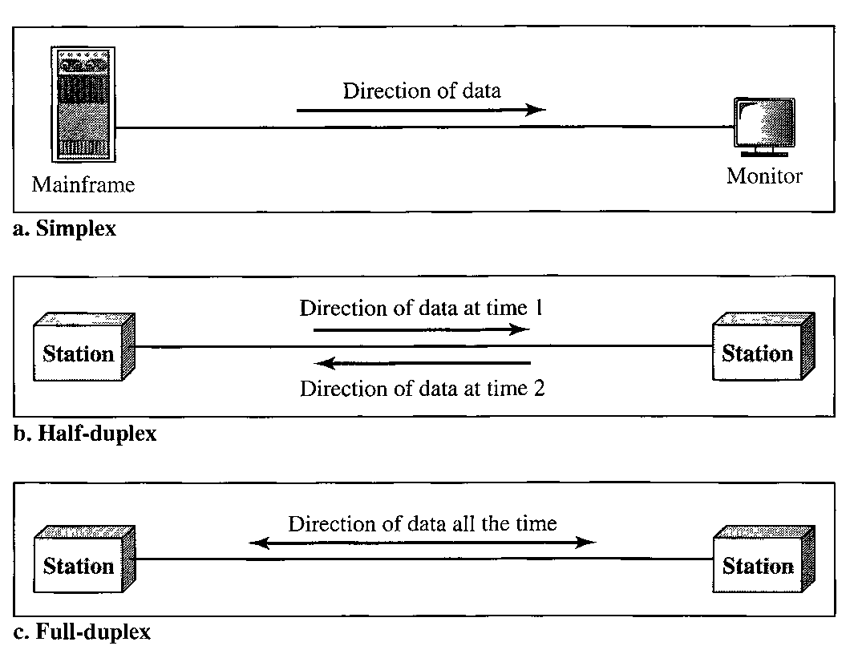

Simplex
In simplex mode, the communication is unidirectional, as on a one-way street. Only one of the two devices on a link can transmit; the other can only receive. Keyboards and traditional monitors are examples of simplex devices. The keyboard can only introduce input; the monitor can only accept output. The simplex mode can use the entire capacity of the channel to send data in one direction.

Half-Duplex
In half-duplex mode, each station can both transmit and receive, but not at the same time. When one device is sending, the other can only receive, and vice versa. In a half-duplex transmission, the entire capacity of a channel is taken over by whichever of the two devices is transmitting at the time. Walkie-talkies and CB (citizens band) radios are both half-duplex systems.
The half-duplex mode is used in cases where there is no need for communication in both directions at the same time; the entire capacity of the channel can be utilized for each direction.

Full-Duplex
In full-duplex made (also, called duplex), both stations can transmit and receive simultaneously. In full-duplex mode, signals going in one direction share the capacity of the link with signals going in the other direction. This sharing can occur in two ways: Either the link must contain two physically separate transmission paths, one for sending and the other for receiving; or the capacity of the channel is divided between signals travelling in both directions.
One common example of full-duplex communication is the telephone network. The full-duplex mode is used when communication in both directions is required all the time. The capacity of the channel, however, must be divided between the two directions.

1.2 NETWORKS

A network is a set of devices (often referred to as nodes) connected by communication links. A node can be a computer, printer, or any other device capable of sending and/or receiving data generated by other nodes on the network.

Distributed Processing

Most networks use distributed processing, in which a task is divided among multiple computers. Instead of one single large machine being responsible for all aspects of a process, separate computers (usually a personal computer or workstation) handle a subset.

Network Criteria

A network must be able to meet a certain number of criteria. The most important of these are performance, reliability, and security.

Performance
Performance can be measured in many ways, including transit time and response time. Transit time is the amount of time required for a message to travel from one device to another. Response time is the elapsed time between an inquiry and a response. The performance of a network depends on a number of factors, including the number of users, the type of transmission medium, the capabilities of the connected hardware, and the efficiency of the software. Performance is often evaluated by two networking metrics: throughput and delay.
We often need more throughput and less delay.

Reliability
In addition to accuracy of delivery, network reliability is measured by the frequency of failure, the time it takes a link to recover from a failure, and the network's robustness in a catastrophe.

Security
Network security issues include protecting data from unauthorized access, protecting data from damage and development, and implementing policies and procedures for recovery from breaches and data losses.
Physical Structures

Type of Connection

A network is two or more devices connected through links. A link is a communications pathway that transfers data from one device to another. For communication to occur, two devices must be connected in some way to the same link at the same time. There are two possible types of connections: point-to-point and multipoint.

Point-to-Point A point-to-point connection provides a dedicated link between two devices. The entire capacity of the link is reserved for transmission between those two devices. Most point-to-point connections use an actual length of wire or cable to connect the two ends, but other options, such as microwave or satellite links, are also possible.
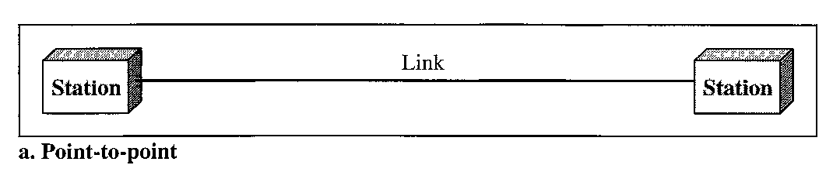

Multipoint A multipoint (also called multidrop) connection is one in which more than two specific devices share a single link. In a multipoint environment, the capacity of the channel is shared, either spatially or temporally. If several devices can use the link simultaneously, it is a spatially shared connection. If users must take turns, it is a timeshared connection.
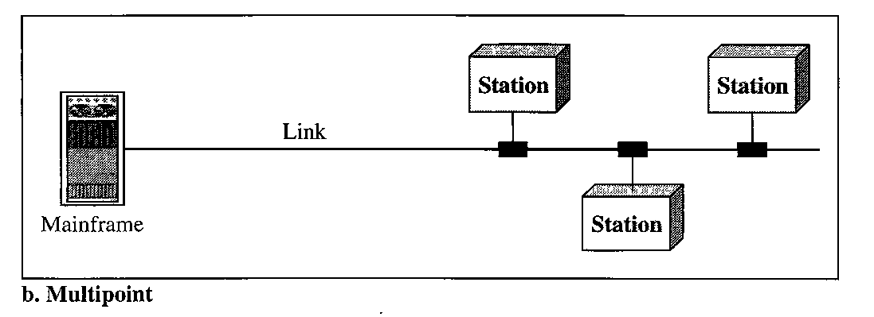

Physical Topology

The term physical topology refers to the way in which a network is laid out physically. Two or more devices connect to a link; two or more links form a topology. The topology of a network is the geometric representation of the relationship of all the links and linking devices (usually called nodes) to one another. There are four basic topologies possible: mesh, star, bus, and ring.
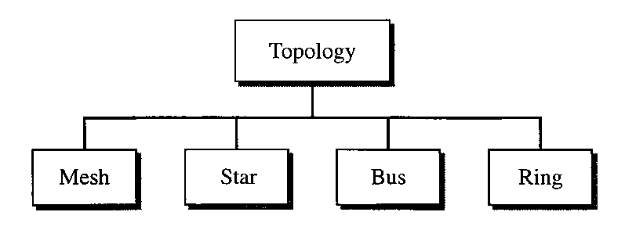

Mesh In a mesh topology, every device has a dedicated point-to-point link to every other device. The term dedicated means that the link carries traffic only between the two devices it connects. To find the number of physical links in a fully connected mesh network with n nodes, we first consider that each node must be connected to every other node. Node 1 must be connected to n-1 nodes, node 2 must be connected to n-1 nodes, and finally node n must be connected to n-1 nodes. We need n(n-1) physical links. However, if each physical link allows communication in both directions (duplex mode), we can divide the number of links by 2. In other words, we can say that in a mesh topology, we need
n(n - 1) / 2
duplex-mode links.
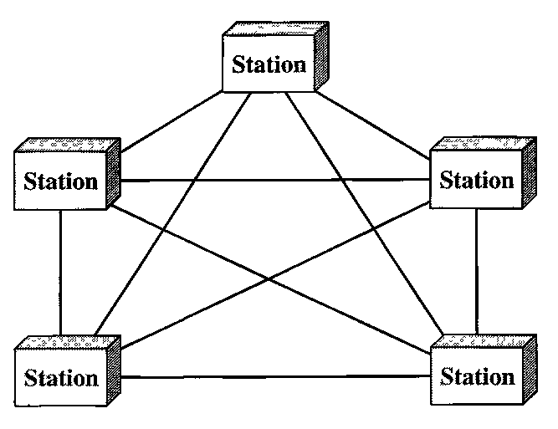

A mesh offers several advantages over other network topologies.
- The use of dedicated links guarantees that each connection can carry its own data load, thus eliminating the traffic problems that can occur when links must be shared by multiple devices.
- A mesh topology is robust. If one link becomes unusable, it does not incapacitate the entire system.
- There is the advantage of privacy or security. When every message travels along a dedicated line, only the intended recipient sees it. Physical boundaries prevent other users from gaining access to messages.
- Point-to-point links make fault identification and fault isolation easy. Traffic can be routed to avoid links with suspected problems. This facility enables the network manager to discover the precise location of the fault and aids in finding its cause and solution.

The main disadvantages of a mesh are related to the amount of cabling and the number of I/O ports required.
- Because every device must be connected to every other device, installation and reconnection are difficult.
- The sheer bulk of the wiring can be greater than the available space (in walls, ceilings, or floors) can accommodate.
- The hardware required to connect each link (I/O ports and cable) can be prohibitively expensive.
For these reasons a mesh topology is usually implemented in a limited fashion, for example, as a backbone connecting the main computers of a hybrid network that can include several other topologies.

Star Topology In a star topology, each device has a dedicated point-to-point link only to a central controller, usually called a hub. The devices are not directly linked to one another. Unlike a mesh topology, a star topology does not allow direct traffic between devices. The controller acts as an exchange: If one device wants to send data to another, it sends the data to the controller, which then relays the data to the other connected device.
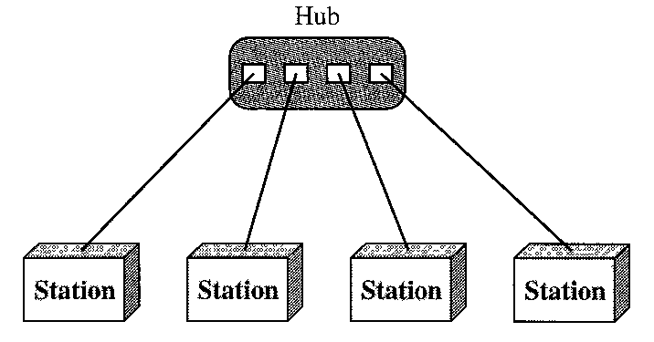

Advantages:
- A star topology is less expensive than a mesh topology. In a star, each device needs only one link and one I/O port to connect it to any number of others. This factor also makes it easy to install and reconfigure. Far less cabling needs to be housed, and additions, moves, and deletions involve only one connection: between that device and the hub.
- Other advantages include robustness. If one link fails, only that link is affected. All other links remain active. This factor also lends itself to easy fault identification and fault isolation. As long as the hub is working, it can be used to monitor link problems and bypass defective links.

Disadvantages:
- One big disadvantage of a star topology is the dependency of the whole topology on one single point, the hub. If the hub goes down, the whole system is dead.
- Although a star requires far less cable than a mesh, each node must be linked to a central hub. For this reason, often more cabling is required in a star than in some other topologies.

Bus Topology The preceding examples all describe point-to-point connections. A bus topology, on the other hand, is multipoint. One long cable acts as a backbone to link all the devices in a network.
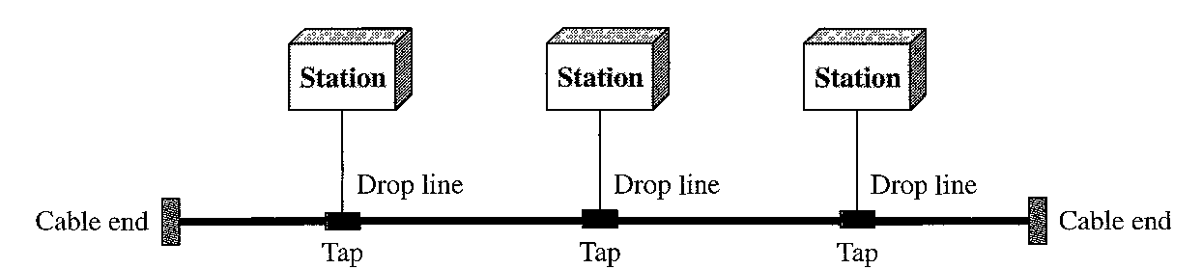

Nodes are connected to the bus cable by drop lines and taps. A drop line is a connection running between the device and the main cable. A tap is a connector that either splices into the main cable or punctures the sheathing of a cable to create a contact with the metallic core. As a signal travels along the backbone, some of its energy is transformed into heat. Therefore, it becomes weaker and weaker as it travels farther and farther. For this reason there is a limit on the number of taps a bus can support and on the distance between those taps.

Advantages:
- Advantages of a bus topology include ease of installation. Backbone cable can be laid along the most efficient path, then connected to the nodes by drop lines of various lengths. In this way, a bus uses less cabling than mesh or star topologies.
- In a bus, redundancy is eliminated. Only the backbone cable stretches through the entire facility. Each drop line has to reach only as far as the nearest point on the backbone.

Disadvantages:
- Disadvantages include difficult reconnection and fault isolation. A bus is usually designed to be optimally efficient at installation. It can therefore be difficult to add new devices.
- Signal reflection at the taps can cause degradation in quality. This degradation can be controlled by limiting the number and spacing of devices connected to a given length of cable. Adding new devices may therefore require modification or replacement of the backbone.
- a fault or break in the bus cable stops all transmission, even between devices on the same side of the problem. The damaged area reflects signals back in the direction of origin, creating noise in both directions.

Ring Topology In a ring topology, each device has a dedicated point-to-point connection with only the two devices on either side of it. A signal is passed along the ring in one direction, from device to device, until it reaches its destination. Each device in the ring incorporates a repeater. When a device receives a signal intended for another device, its repeater regenerates the bits and passes them along.
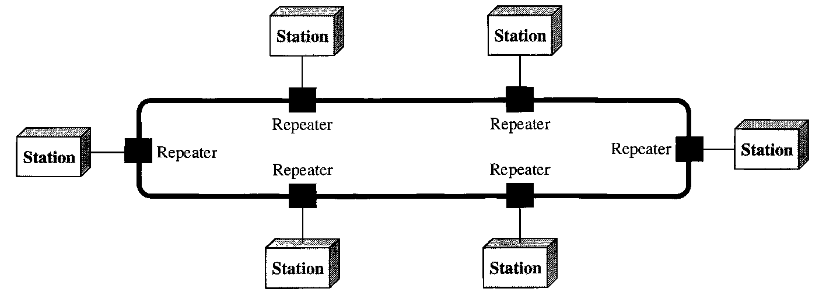
Advantages:
- A ring is relatively easy to install and reconfigure. Each device is linked to only its immediate neighbors.
- To add or delete a device requires changing only two connections. The only constraints are media and traffic considerations (maximum ring length and number of devices).
- In addition, fault isolation is simplified. Generally in a ring, a signal is circulating at all times. If one device does not receive a signal within a specified period, it can issue an alarm. The alarm alerts the network operator to the problem and its location.

Disadvantages:
- Unidirectional traffic can be a disadvantage. In a simple ring, a break in the ring (such as a disabled station) can disable the entire network. This weakness can be solved by using a dual ring or a switch capable of closing off the break.

Hybrid Topology A network can be hybrid. For example, we can have a main star topology with each branch connecting several stations in a bus topology as shown:
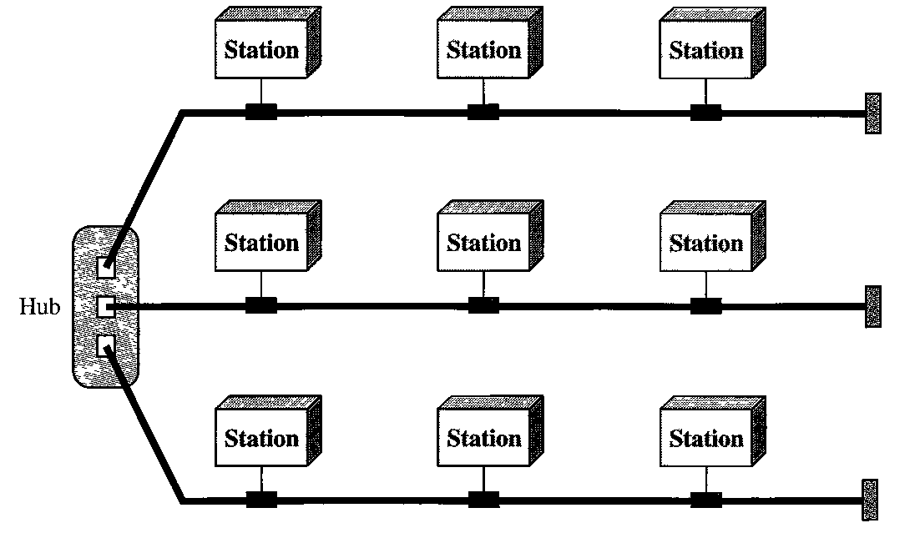

1.3 Network TYPES

Local Area Network

A local area network (LAN) is usually privately owned and links the devices in a single office, building, or campus. Depending on the needs of an organization and the type of technology used, a LAN can be as simple as two PCs and a printer in someone's home office; or it can extend throughout a company and include audio and video peripherals. Currently, LAN size is limited to a few kilometers.
LANs are designed to allow resources to be shared between personal computers or workstations. The resources to be shared can include hardware (e.g., a printer), software (e.g., an application program), or data. A common example of a LAN, found in many business environments, links a workgroup of task-related computers, for example, engineering workstations or accounting PCs. One of the computers may be given a large capacity disk drive and may become a server to clients. Software can be stored on this central server and used as needed by the whole group.
In addition to size, LANs are distinguished from other types of networks by their transmission media and topology. In general, a given LAN will use only one type of transmission medium. The most common LAN topologies are bus, ring, and star.
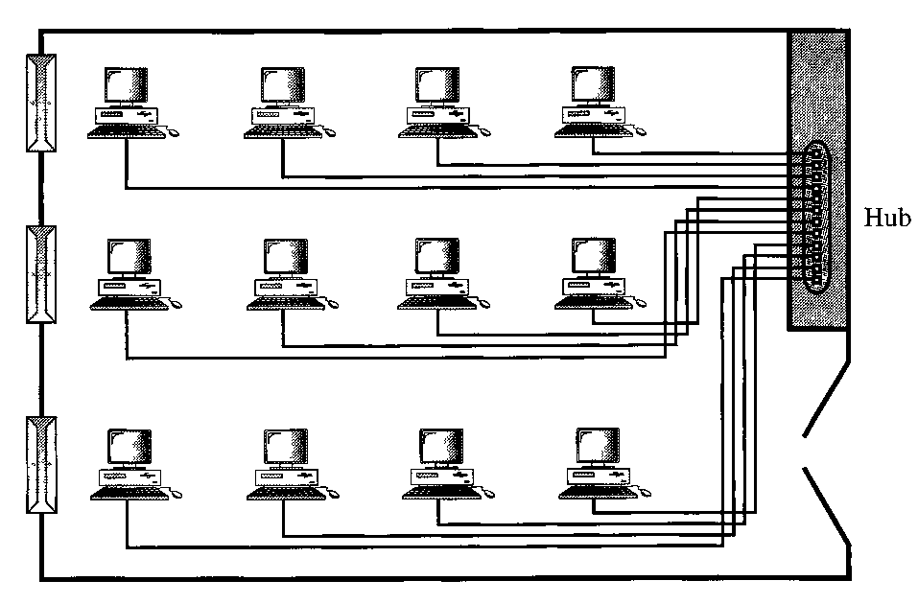

Wide Area Network

A wide area network (WAN) provides long-distance transmission of data, image, audio, and video information over large geographic areas that may comprise a country, a continent, or even the whole world.
A WAN can be as complex as the backbones that connect the Internet or as simple as a dial-up line that connects a home computer to the Internet. We normally refer to the first as a switched WAN and to the second as a point-to-point WAN. The switched WAN connects the end systems, which usually comprise a router (internet-working connecting device) that connects to another LAN or WAN. The point-to-point
WAN is normally a line leased from a telephone or cable TV provider that connects a home computer or a small LAN to an Internet service provider (ISP). This type of WAN is often used to provide Internet access.

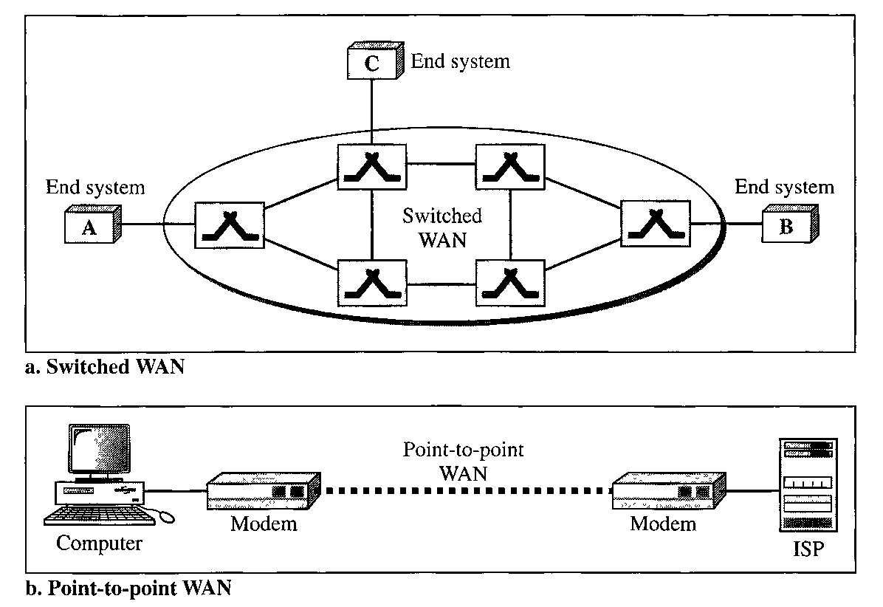

Metropolitan Area Networks

A metropolitan area network (MAN) is a network with a size between a LAN and a WAN. It normally covers the area inside a town or a city. It is designed for customers who need a high-speed connectivity, normally to the Internet, and have endpoints spread over a city or part of city. A good example of a MAN is the part of the telephone company network that can provide a high-speed DSL line to the customer.

Interconnection of Networks: Internetwork

Today, it is very rare to see a LAN, a MAN, or a LAN in isolation; they are connected to one another. When two or more networks are connected, they become an internetwork, or internet.
As an example, assume that an organization has two offices in separate cities. One established office has a bus topology LAN; the other office has a star topology LAN. The president lives in some other city and needs to have control over the company from her home. To create a backbone WAN for connecting these three entities (two LANs and the president's computer), a switched WAN (operated by a service provider such as a telecom company) has been leased. To connect the LANs to this switched WAN, however, three point-to-point WANs are required. These point-to-point WANs can be a high-speed DSL line offered by a telephone company or a cable modem line offered by a cable TV provider as shown:
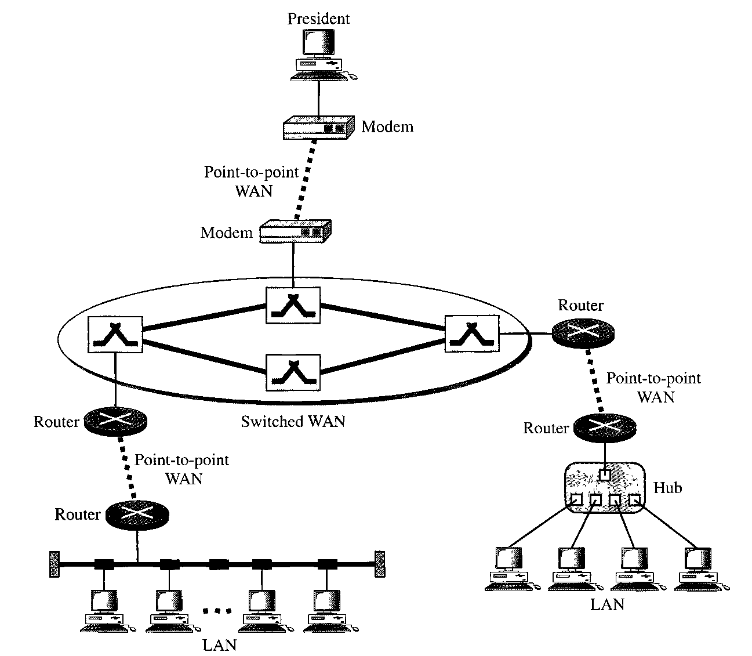

Chapter 2
Network Models

2.1 LAYERED TASKS

As an example, let us consider two friends who communicate through postal mail. The process of sending a letter to a friend would be complex if there were no services available from the post office. The figure shows the steps in this task.
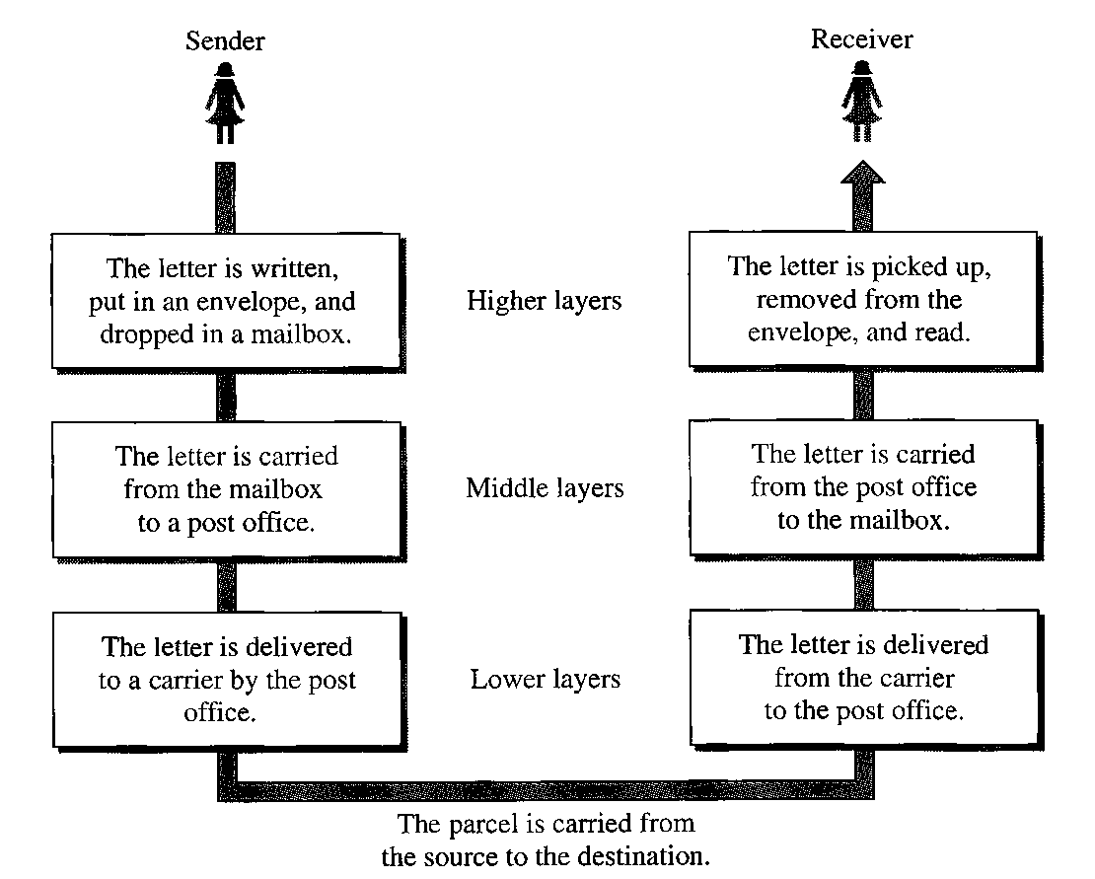

Sender, Receiver, and Carrier

In Figure 2.1 we have a sender, a receiver, and a carrier that transports the letter. There is a hierarchy of tasks.

At the Sender Site
The activities that take place at the sender site, in order, are:
- Higher layer. The sender writes the letter, inserts the letter in an envelope, writes the sender and receiver addresses, and drops the letter in a mailbox.
- Middle layer. The letter is picked up by a letter carrier and delivered to the post office.
- Lower layer. The letter is sorted at the post office; a carder transports the letter.

On the Way
The letter is then on its way to the recipient. On the way to the recipient's local post office, the letter may actually go through a central office. In addition, it may be trans- ported by truck, train, airplane, boat, or a combination of these.

At the Receiver Site
- Lower layer. The carrier transports the letter to the post office.
- Middle layer. The letter is sorted and delivered to the recipient's mailbox.
- Higher layer. The receiver picks up the letter, opens the envelope, and reads it.

Hierarchy

According to our analysis, there are three different activities at the sender site and another three activities at the receiver site. The task of transporting the letter between the sender and the receiver is done by the carrier. Something that is not obvious immediately is that the tasks must be done in the order given in the hierarchy. At the sender site, the letter must be written and dropped in the mailbox before being picked up by the letter carrier and delivered to the post office. At the receiver site, the letter must be dropped in the recipient mailbox before being picked up and read by the recipient.

Services
Each layer at the sending site uses the services of the layer immediately below it. The sender at the higher layer uses the services of the middle layer. The middle layer uses the services of the lower layer. The lower layer uses the services of the carrier. The layered model that dominated data communications and networking literature before 1990 was the Open Systems Interconnection (OSI) model.

2.2 THE OSI MODEL

The OSI model is a layered framework for the design of network systems that allows communication between all types of computer systems. It consists of seven separate but related layers, each of which defines a part of the process of moving information across a network.
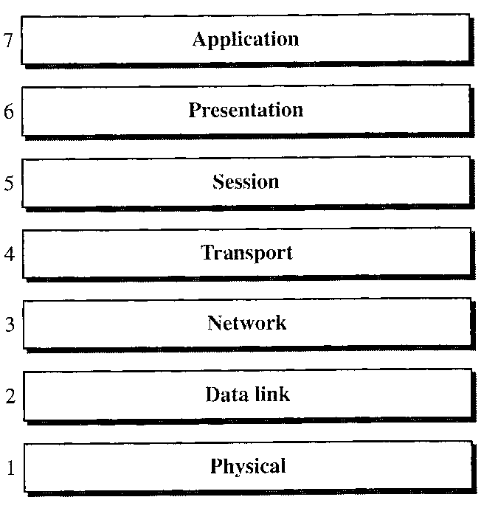

Layered Architecture

The OSI model is composed of seven ordered layers: physical (layer 1), data link (layer 2), network (layer 3), transport (layer 4), session (layer 5), presentation (layer 6), and application (layer 7). The following figure shows the layers involved when a message is sent from device A to device B. As the message travels from A to B, it may pass through many intermediate nodes. These intermediate nodes usually involve only the first three layers of the OSI model.
Within a single machine, each layer calls upon the services of the layer just below it. Layer 3, for example, uses the services provided by layer 2 and provides services for layer 4. Between machines, layer x on one machine communicates with layer x on another machine. This communication is governed by an agreed-upon series of rules and conventions called protocols. The processes on each machine that communicate at a given layer are called peer-to-peer processes. Communication between machines is therefore a peer-to-peer process using the protocols appropriate to a given layer.

Peer-to-Peer Processes

At the physical layer, communication is direct: In the figure below, device A sends a stream of bits to device B (through intermediate nodes). At the higher layers, however, communication must move down through the layers on device A, over to device B, and then back up through the layers. Each layer in the sending device adds its own information to the message it receives from the layer just above it and passes the whole package to the layer just below it.
At layer 1 the entire package is converted to a form that can be transmitted to the receiving device. At the receiving machine, the message is unwrapped layer by layer, with each process receiving and removing the data meant for it. For example, layer 2 removes the data meant for it, then passes the rest to layer 3. Layer 3 then removes the data meant for it and passes the rest to layer 4, and so on.
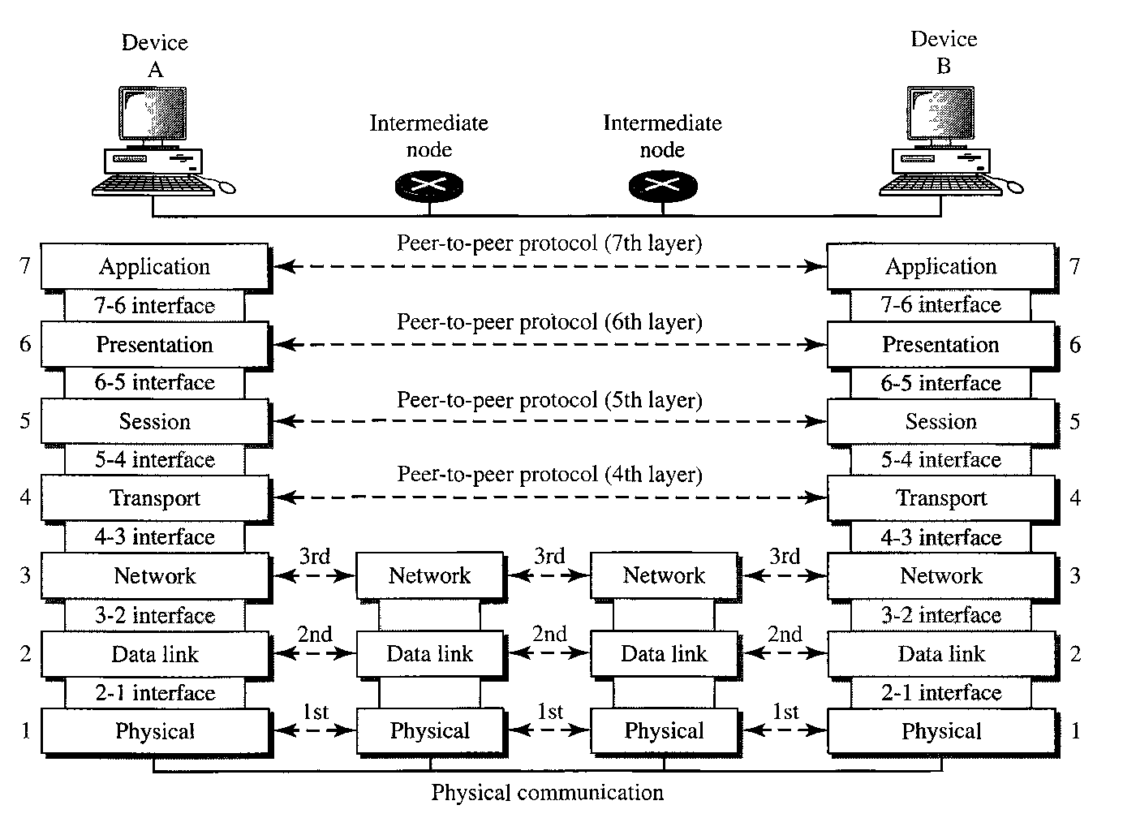
Figure 2.3

Interfaces Between Layers

The passing of the data and network information down through the layers of the sending device and back up through the layers of the receiving device is made possible by an interface between each pair of adjacent layers. Each interface defines the information and services a layer must provide for the layer above it. Well-defined interfaces and layer functions provide modularity to a network. As long as a layer provides the
expected services to the layer above it, the specific implementation of its functions can be modified or replaced without requiring changes to the surrounding layers.

Organization of the Layers

The seven layers can be thought of as belonging to three subgroups. Layers 1, 2, and 3 - physical, data link, and network - are the network support layers; they deal with the physical aspects of moving data from one device to another (such as electrical specifications, physical connections, physical addressing, and transport timing and reliability). Layers 5, 6, and 7 - session, presentation, and application - can be thought of as the user support layers; they allow interoperability among unrelated software systems. Layer 4, the transport layer, links the two subgroups and ensures that what the lower layers have transmitted is in a form that the upper layers can use. The upper OSI layers are almost always implemented in software; lower layers are a combination of hardware and software, except for the physical layer, which is mostly hardware.
The following figure gives an overall view of the OSI layers, D7 means the data unit at layer 7, D6 means the data unit at layer 6, and so on. The process starts at layer 7 (the application layer), then moves from layer to layer in descending, sequential order. At each layer, a header, or possibly a trailer, can be added to the data unit. Commonly, the trailer is added only at layer 2. When the formatted data unit passes through the physical layer (layer 1), it is changed into an electromagnetic signal and transported along a physical link.
Upon reaching its destination, the signal passes into layer 1 and is transformed back into digital form. The data units then move back up through the OSI layers. As each block of data reaches the next higher layer, the headers and trailers attached to it at the corresponding sending layer are removed, and actions appropriate to that layer are taken. By the time it reaches layer 7, the message is again in a form appropriate to the application and is made available to the recipient.
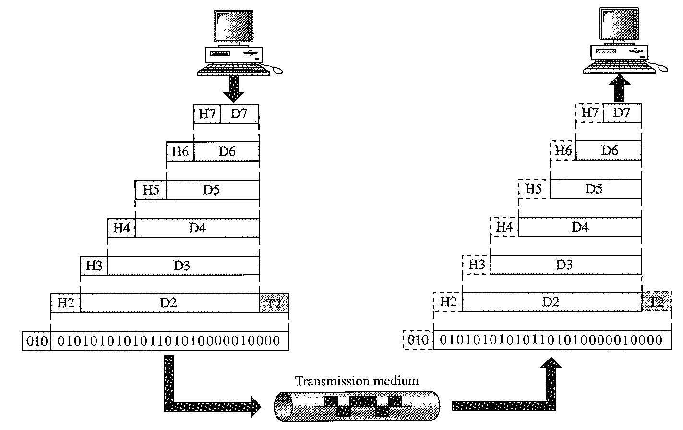

Encapsulation

Figure 2.3 reveals another aspect of data communications in the OSI model: encapsulation. A packet (header and data) at level 7 is encapsulated in a packet at level 6. The whole packet at level 6 is encapsulated in a packet at level 5, and so on. In other words, the data portion of a packet at level N - 1 carries the whole packet
(data and header and maybe trailer) from level N. The concept is called encapsulation; level N- 1 is not aware of which part of the encapsulated packet is data and which part is the header or trailer. For level N- 1, the whole packet coming from level N is treated as one integral unit.

2.3 LAYERS IN THE OSI MODEL

Physical Layer

The physical layer coordinates the functions required to carry a bit stream over a physical medium. It deals with the mechanical and electrical specifications of the interface and transmission medium. It also defines the procedures and functions that physical devices and interfaces have to perform for transmission to occur. The following figure shows the position of the physical layer with respect to the transmission medium and the data link layer.

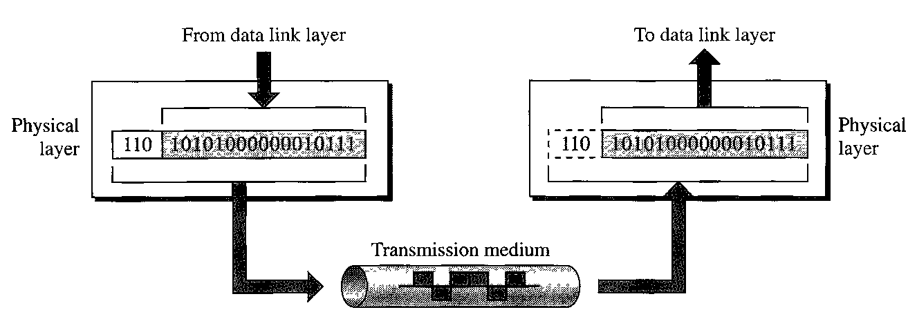

The physical layer is also concerned with the following:
- Physical characteristics of interfaces and medium. The physical layer defines the characteristics of the interface between the devices and the transmission medium. It also defines the type of transmission medium.
- Representation of bits. The physical layer data consists of a stream of bits (sequence of 0s or ls) with no interpretation. To be transmitted, bits must be encoded into signals - electrical or optical. The physical layer defines the type of encoding (how 0s and 1s are changed to signals).
- Data rate. The transmission rate--the number of bits sent each second--is also defined by the physical layer. In other words, the physical layer defines the duration of a bit, which is how long it lasts.
- Synchronization of bits. The sender and receiver not only must use the same bit rate but also must be synchronized at the bit level. In other words, the sender and the receiver clocks must be synchronized.
- Line configuration. The physical layer is concerned with the connection of devices to the media. In a point-to-point configuration, two devices are connected through a dedicated link. In a multipoint configuration, a link is shared among several devices.
- Physical topology. The physical topology defines how devices are connected to make a network. Devices can be connected by using a mesh topology (every device is connected to every other device), a star topology (devices are connected through a central device), a ring topology (each device is connected to the next, forming a ring), a bus topology (every device is on a common link), or a hybrid topology (this is a combination of two or more topologies).
- Transmission mode. The physical layer also defines the direction of transmission between two devices: simplex, half-duplex, or full-duplex. In simplex mode, only one device can send; the other can only receive. The simplex mode is a one-way communication. In the half-duplex mode, two devices can send and receive, but not at the same time. In a full-duplex (or simply duplex) mode, two devices can send and receive at the same time.

Data Link Layer

The data link layer transforms the physical layer, a raw transmission facility, to a reliable link. It makes the physical layer appear error-free to the upper layer (network layer). The figure shows the relationship of the data link layer to the network and physical layers.

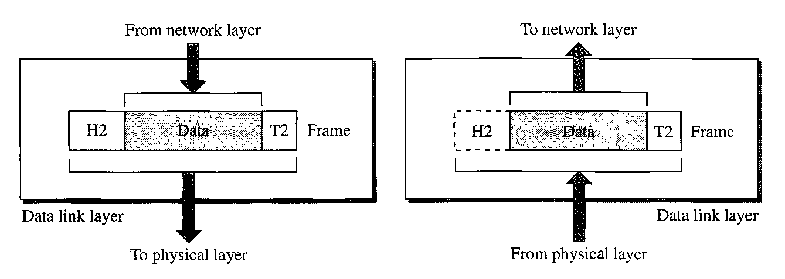

Other responsibilities of the data link layer include the following:
- Framing. The data link layer divides the stream of bits received from the network layer into manageable data units called frames.
- Physical addressing. If frames are to be distributed to different systems on the network, the data link layer adds a header to the frame to define the sender and/or receiver of the frame. If the frame is intended for a system outside the sender's network, the receiver address is the address of the device that connects the network to the next one.
- Flow control. If the rate at which the data are absorbed by the receiver is less than the rate at which data are produced in the sender, the data link layer imposes a flow control mechanism to avoid overwhelming the receiver.
- Error control. The data link layer adds reliability to the physical layer by adding mechanisms to detect and retransmit damaged or lost frames. It also uses a mechanism to recognize duplicate frames. Error control is normally achieved through a trailer added to the end of the frame.
- Access control. When two or more devices are connected to the same link, data link layer protocols are necessary to determine which device has control over the link at any given time.

The figure illustrates hop-to-hop (node-to-node) delivery by the data link layer.

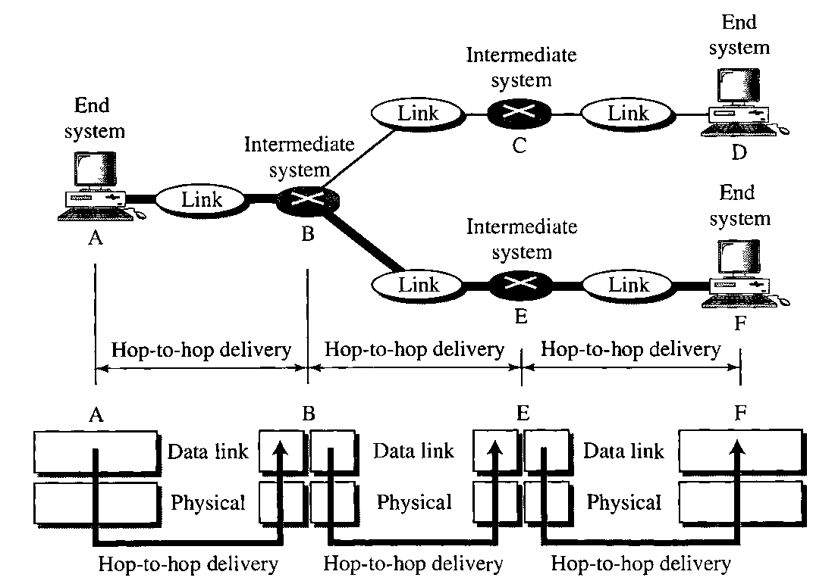

Communication at the data link layer occurs between two adjacent nodes. To send data from A to F, three partial deliveries are made. First, the data link layer at A sends a frame to the data link layer at B (a router). Second, the data link layer at B sends a new frame to the data link layer at E. Finally, the data link layer at E sends a new frame to the data link layer at F.

Network Layer

The network layer is responsible for the source-to-destination delivery of a packet, possibly across multiple networks (links). Whereas the data link layer oversees the delivery of the packet between two systems on the same network (links), the network layer ensures that each packet gets from its point of origin to its final destination.
If two systems are connected to the same link, there is usually no need for a network layer. However, if the two systems are attached to different networks (links) with connecting devices between the networks (links), there is often a need for the network layer to accomplish source-to-destination delivery. The figure shows the relationship of the network layer to the data link and transport layers.

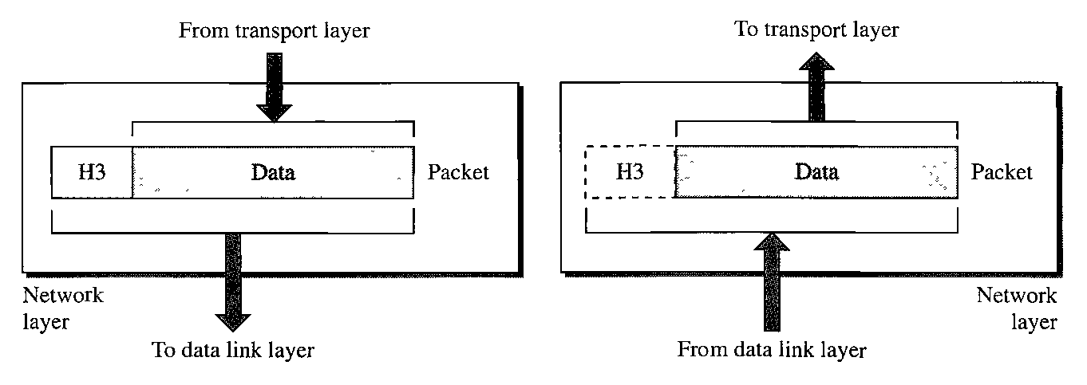

Other responsibilities of the network layer include the following:

- Logical addressing. The physical addressing implemented by the data link layer handles the addressing problem locally. If a packet passes the network boundary, we need another addressing system to help distinguish the source and destination systems. The network layer adds a header to the packet coming from the upper layer that, among other things, includes the logical addresses of the sender and receiver.
- Routing. When independent networks or links are connected to create internetworks (network of networks) or a large network, the connecting devices (called routers or switches) route or switch the packets to their final destination. One of the functions of the network layer is to provide this mechanism.
The figure illustrates end-to-end delivery by the network layer.

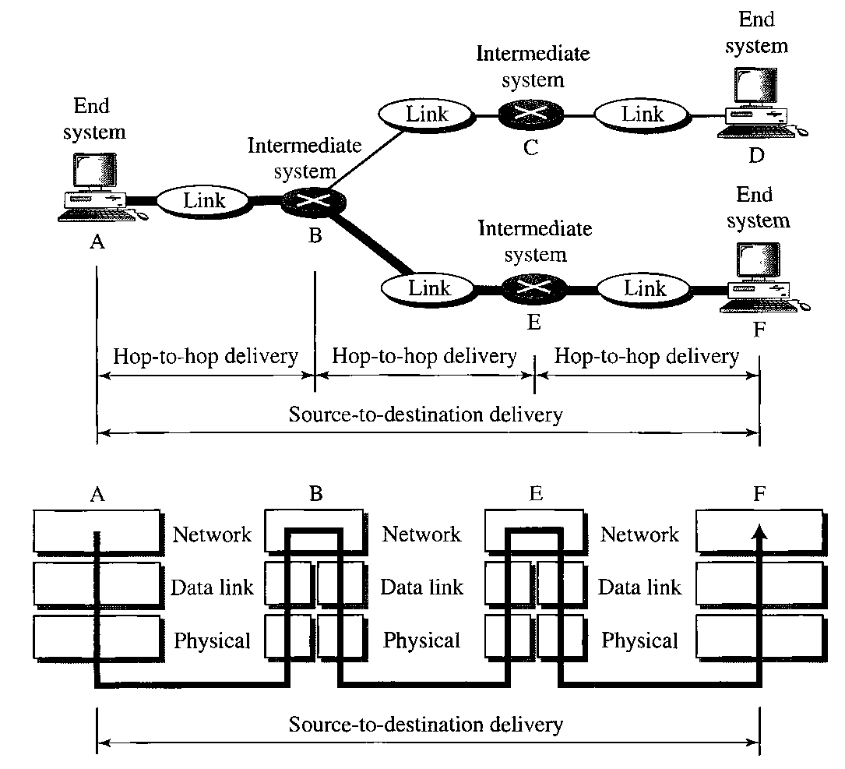

The network layer at A sends the packet to the network layer at B. When the packet arrives at router B, the
router makes a decision based on the final destination (F) of the packet. As we will see in later chapters, router B uses its routing table to find that the next hop is router E. The network layer at B, therefore, sends the packet to the network layer at E. The network layer at E, in turn, sends the packet to the network layer at F.

Transport Layer

The transport layer is responsible for process-to-process delivery of the entire message. A process is an application program running on a host. Whereas the network layer oversees source-to-destination delivery of individual packets, it does not recognize any relationship between those packets. It treats each one independently, as though each piece belonged to a separate message, whether or not it does. The transport layer, on the other hand, ensures that the whole message arrives intact and in order, overseeing both error control and flow control at the source-to-destination level. The figure shows the relationship of the transport layer to the network and session layers.
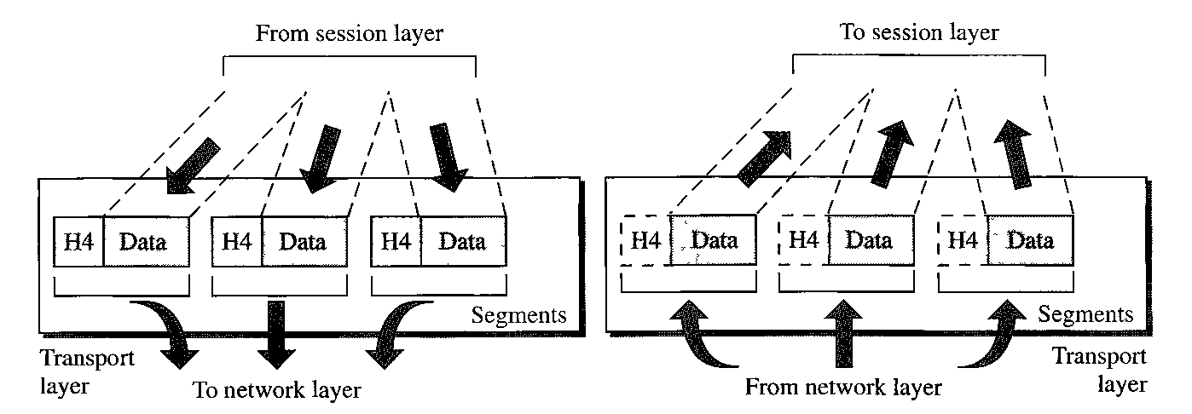

Other responsibilities of the transport layer include the following:
- Service-point addressing. Computers often run several programs at the same time. For this reason, source-to-destination delivery means delivery not only from one computer to the next but also from a specific process (running program) on one computer to a specific process (running program) on the other. The transport layer header must therefore include a type of address called a service-point address (or port address). The network layer gets each packet to the correct computer; the transport layer gets the entire message to the correct process on that computer.
- Segmentation and reassembly. A message is divided into transmittable segments, with each segment containing a sequence number. These numbers enable the transport layer to reassemble the message correctly upon arriving at the destination and to identify and replace packets that were lost in transmission.
- Connection control. The transport layer can be either connectionless or connection-oriented. A connectionless transport layer treats each segment as an independent packet and delivers it to the transport layer at the destination machine. A connection-oriented transport layer makes a connection with the transport layer at the destination machine first before delivering the packets. After all the data are transferred, the connection is terminated.
- Flow control. Like the data link layer, the transport layer is responsible for flow control. However, flow control at this layer is performed end to end rather than across a single link.
- Error control. Like the data link layer, the transport layer is responsible for error control. However, error control at this layer is performed process-to-process rather than across a single link. The sending transport layer makes sure that the entire message arrives at the receiving transport layer without error (damage, loss, or duplication). Error correction is usually achieved through retransmission.

The figure illustrates process-to-process delivery by the transport layer.
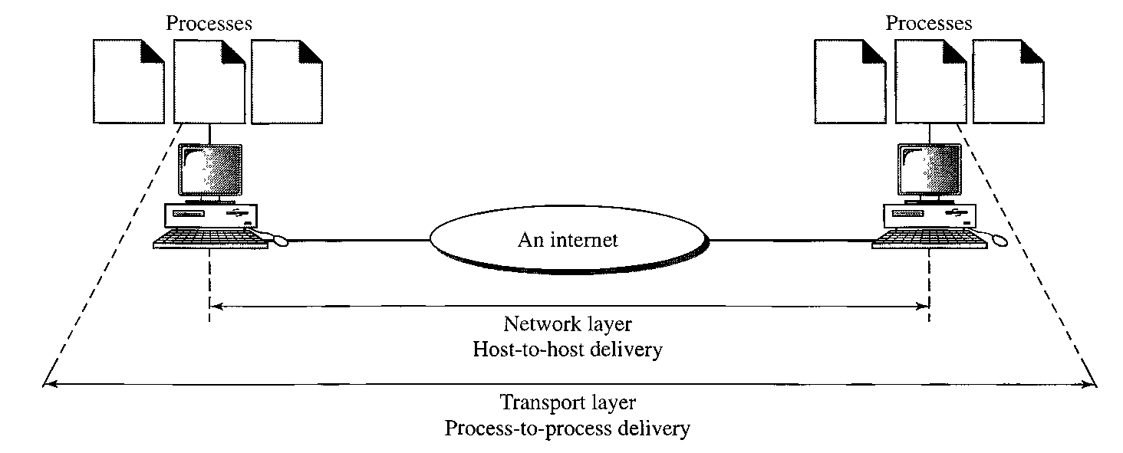

Session Layer

The services provided by the first three layers (physical, data link, and network) are not sufficient for some processes. The session layer is the network dialog controller. It establishes, maintains, and synchronizes the interaction among communicating systems.

Specific responsibilities of the session layer include the following:
- Dialog control. The session layer allows two systems to enter into a dialog. It allows the communication between two processes to take place in either half- duplex (one way at a time) or full-duplex (two ways at a time) mode.
- Synchronization. The session layer allows a process to add checkpoints, or synchronization points, to a stream of data. For example, if a system is sending a file of 2000 pages, it is advisable to insert checkpoints after every 100 pages to ensure that each 100-page unit is received and acknowledged independently. In this case, if a crash happens during the transmission of page 523, the only pages that need to be resent after system recovery are pages 501 to 523. Pages previous to 501 need not be resent.
The figure illustrates the relationship of the session layer to the transport and presentation layers.
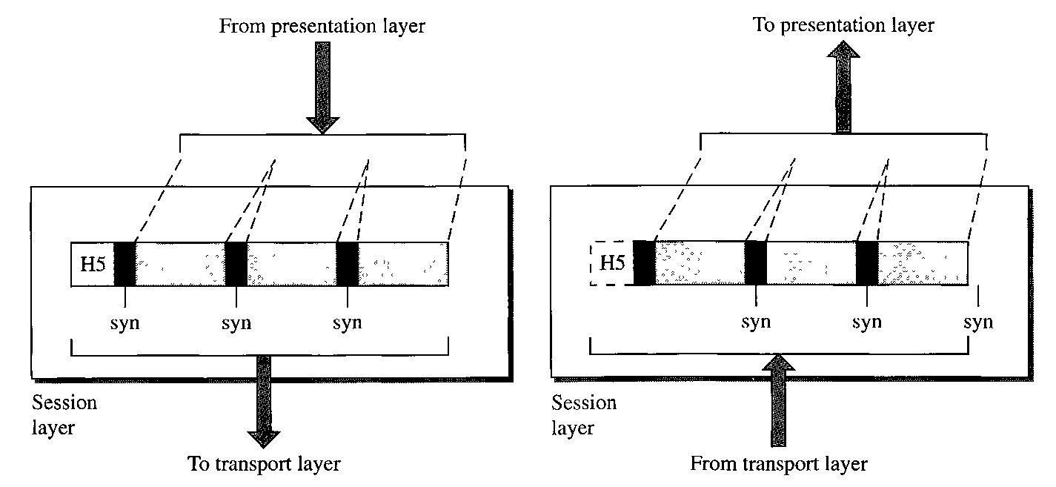
Presentation Layer

The presentation layer is concerned with the syntax and semantics of the information exchanged between two systems. The figure shows the relationship between the presentation layer and the application and session layers.
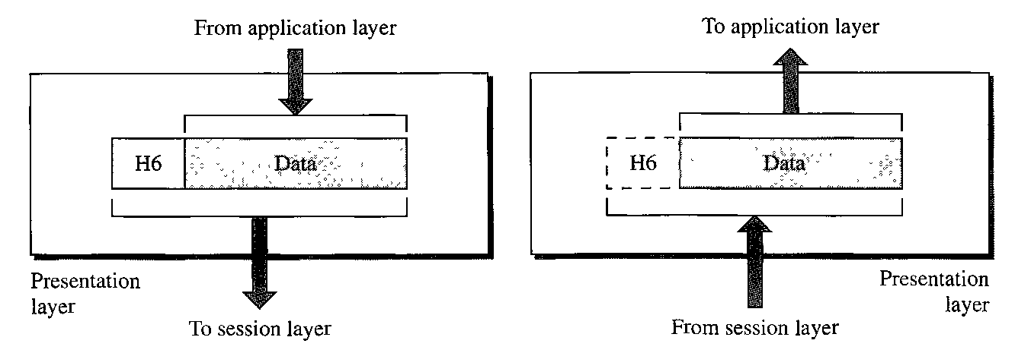
Specific responsibilities of the presentation layer include the following:
- Translation. The processes (running programs) in two systems are usually exchanging information in the form of character strings, numbers, and so on. The information must be changed to bit streams before being transmitted. Because different computers use different encoding systems, the presentation layer is responsible for interoperability between these different encoding methods. The presentation layer at the sender changes the information from its sender-dependent format into a common format. The presentation layer at the receiving machine changes the common format into its receiver-dependent format.
- Encryption. To carry sensitive information, a system must be able to ensure privacy. Encryption means that the sender transforms the original information to another form and sends the resulting message out over the network. Decryption reverses the original process to transform the message back to its original form.
- Compression. Data compression reduces the number of bits contained in the information. Data compression becomes particularly important in the transmission of multimedia such as text, audio, and video.

Application Layer

The application layer enables the user, whether human or software, to access the network. It provides user interfaces and support for services such as electronic mail, remote file access and transfer, shared database management, and other types of distributed information services. The figure shows the relationship of the application layer to the user and the presentation layer.
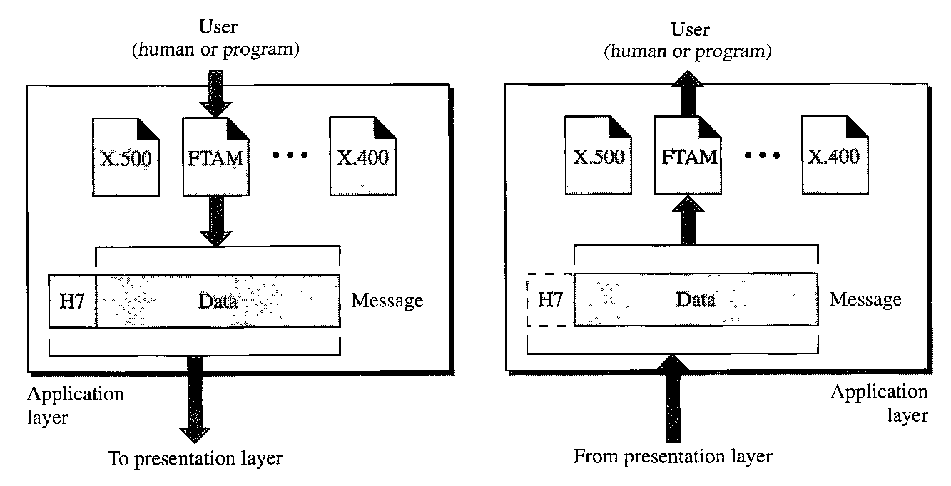

Specific services provided by the application layer include the following:
- Network virtual terminal. A network virtual terminal is a software version of a physical terminal, and it allows a user to log on to a remote host. To do so, the application creates a software emulation of a terminal at the remote host. The user's computer talks to the software terminal which, in turn, talks to the host, and vice versa. The remote host believes it is communicating with one of its own terminals and allows the user to log on.
- File transfer, access, and management. This application allows a user to access files in a remote host (to make changes or read data), to retrieve files from a remote computer for use in the local computer, and to manage or control files in a remote computer locally.
- Mail services. This application provides the basis for e-mail forwarding and storage.
- Directory services. This application provides distributed database sources and access for global information about various objects and services.

2.4 TCP/IP PROTOCOL SUITE

The TCP/IP protocol suite is made of five layers: physical, data link, network, transport, and application. The first four layers provide physical standards, network interfaces, internetworking, and transport functions that correspond to the first four layers of the OSI model. The three topmost layers in the OSI model, however, are represented in TCP/IP by a single layer called the application layer.
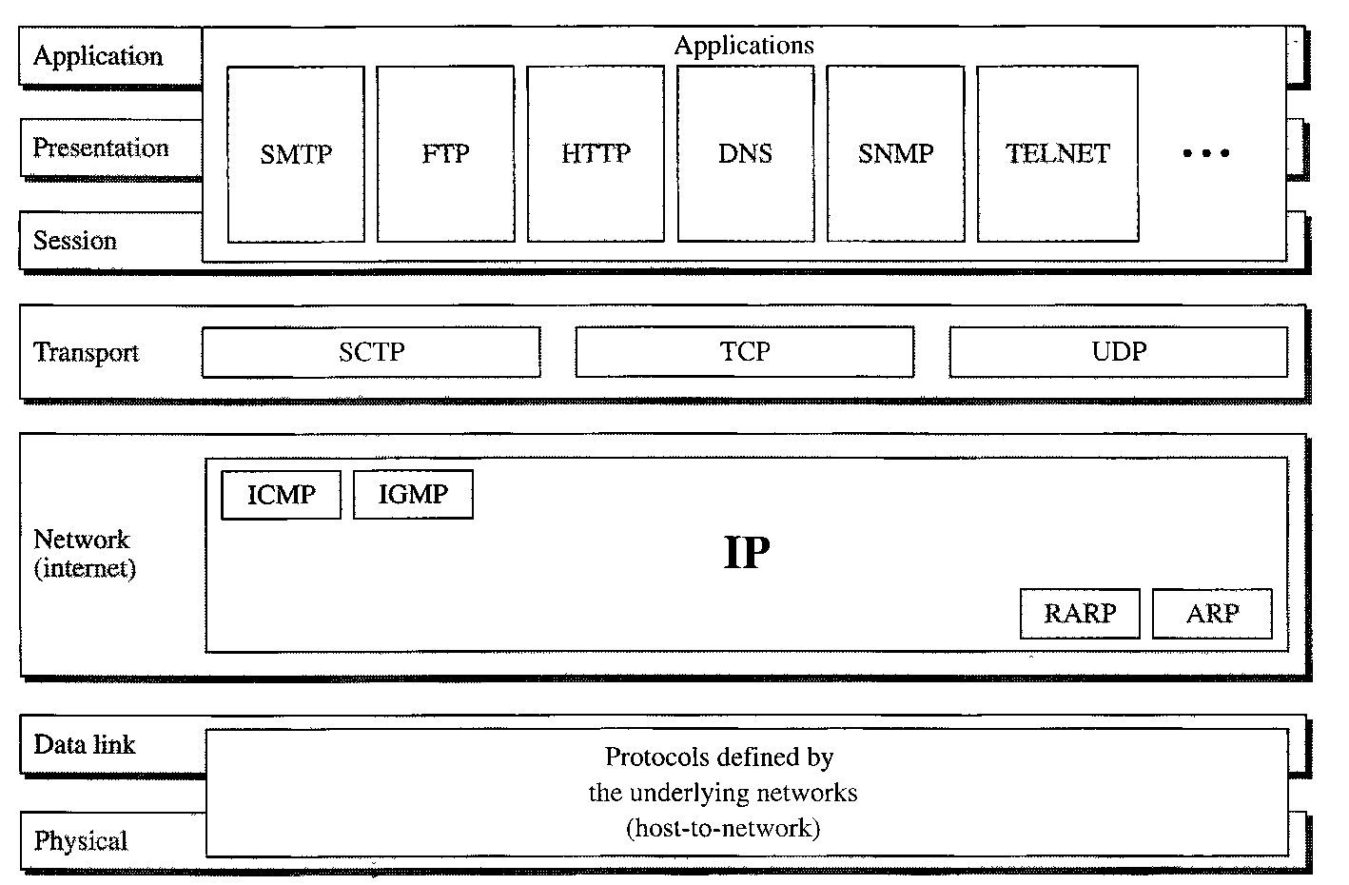

TCP/IP is a hierarchical protocol made up of interactive modules, each of which provides a specific functionality; however, the modules are not necessarily interdependent. Whereas the OSI model specifies which functions belong to each of its layers, the layers of the TCP/IP protocol suite contain relatively independent protocols that can be mixed and matched depending on the needs of the system. The term hierarchical means that each upper-level protocol is supported by one or more lower-level protocols.
At the transport layer, TCP/IP defines three protocols: Transmission Control Protocol (TCP), User Datagram Protocol (UDP), and Stream Control Transmission Protocol (SCTP). At the network layer, the main protocol defined by TCP/IP is the Internetworking Protocol (IP); there are also some other protocols that support data movement in this layer.

Physical and Data Link Layers

At the physical and data link layers, TCP/IP does not define any specific protocol. It supports all the standard and proprietary protocols. A network in a TCP/IP internetwork can be a local-area network or a wide-area network.

Network Layer

At the network layer (or, more accurately, the internetwork layer), TCP/IP supports the Internetworking Protocol. IP, in turn, uses four supporting protocols: ARP, RARP, ICMP, and IGMP.

Internetworking Protocol (IP)
The Internetworking Protocol (IP) is the transmission mechanism used by the TCP/IP protocols. It is an unreliable and connectionless protocol--a best-effort delivery service. The term best effort means that IP provides no error checking or tracking. IP assumes the unreliability of the underlying layers and does its best to get a transmission through to its destination, but with no guarantees.
IP transports data in packets called datagrams, each of which is transported separately. Datagrams can travel along different routes and can arrive out of sequence or be duplicated. IP does not keep track of the routes and has no facility for reordering datagrams once they arrive at their destination.

Address Resolution Protocol
The Address Resolution Protocol (ARP) is used to associate a logical address with a physical address. On a typical physical network, such as a LAN, each device on a link is identified by a physical or station address, usually imprinted on the network interface card (NIC). ARP is used to find the physical address of the node when its Internet address is known.

Reverse Address Resolution Protocol
The Reverse Address Resolution Protocol (RARP) allows a host to discover its Internet address when it knows only its physical address. It is used when a computer is connected to a network for the first time or when a diskless computer is booted.

Internet Control Message Protocol
The Internet Control Message Protocol (ICMP) is a mechanism used by hosts and gateways to send notification of datagram problems back to the sender. ICMP sends query and error reporting messages.

Internet Group Message Protocol
The Internet Group Message Protocol (IGMP) is used to facilitate the simultaneous transmission of a message to a group of recipients.

Transport Layer

Traditionally the transport layer was represented in TCP/IP by two protocols: TCP and UDP. IP is a host-to-host protocol, meaning that it can deliver a packet from one physical device to another. UDP and TCP are transport level protocols responsible for delivery of a message from a process (running program) to another process. A new transport layer protocol, SCTP, has been devised to meet the needs of some newer applications.

User Datagram Protocol
The User Datagram Protocol (UDP) is the simpler of the two standard TCP/IP transport protocols. It is a process-to-process protocol that adds only port addresses, checksum error control, and length information to the data from the upper layer.

Transmission Control Protocol
The Transmission Control Protocol (TCP) provides full transport-layer services to applications. TCP is a reliable stream transport protocol. The term stream, in this context, means connection-oriented: A connection must be established between both ends of a transmission before either can transmit data.
At the sending end of each transmission, TCP divides a stream of data into smaller units called segments. Each segment includes a sequence number for reordering after receipt, together with an acknowledgment number for the segments received. Segments are carried across the internet inside of IP datagrams. At the receiving end, TCP collects each datagram as it comes in and reorders the transmission based on sequence numbers.

Stream Control Transmission Protocol
The Stream Control Transmission Protocol (SCTP) provides support for newer applications such as voice over the Internet. It is a transport layer protocol that combines the best features of UDP and TCP.

Application Layer

The application layer in TCP/IP is equivalent to the combined session, presentation, and application layers in the OSI model. Many protocols are defined at this layer.
Data and Signals

3.1 ANALOG AND DIGITAL

Analog and Digital Data

Data can be analog or digital. The term analog data refers to information that is Continuous; digital data refers to information that has discrete states. For example, an analog clock that has hour, minute, and second hands gives information in a continuous form; the movements of the hands are continuous.
Analog data, such as the sounds made by a human voice, take on continuous values. When someone speaks, an analog wave is created in the air. This can be captured by a microphone and converted to an analog signal or sampled and converted to a digital signal.
Digital data take on discrete values. For example, data are stored in computer memory in the form of Os and 1 s. They can be converted to a digital signal or modulated into an analog signal for transmission across a medium.

Analog and Digital Signals

Like the data they represent, signals can be either analog or digital. An analog signal has infinitely many levels of intensity over a period of time. As the wave moves from value A to value B, it passes through and includes an infinite number of values along its path. A digital signal, on the other hand, can have only a limited number of defined values. Although each value can be any number, it is often as simple as 1 and 0.
The following figure illustrates an analog signal and a digital signal. The curve representing the analog signal passes through an infinite number of points. The vertical lines of the digital signal, however, demonstrate the sudden jump that the signal makes from value to value.

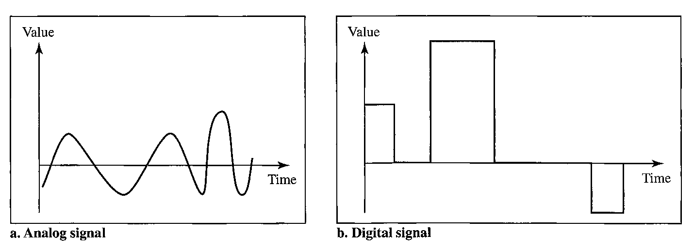

Periodic and Nonperiodic Signals

Both analog and digital signals can take one of two forms: periodic or nonperiodic.
A periodic signal completes a pattern within a measurable time frame, called a period, and repeats that pattern over subsequent identical periods. The completion of one full pattern is called a cycle. A nonperiodic signal changes without exhibiting a pattern or cycle that repeats over time.

3.2 TRANSMISSION IMPAIRMENT

Signals travel through transmission media, which are not perfect. The imperfection causes signal impairment. This means that the signal at the beginning of the medium is not the same as the signal at the end of the medium. What is sent is not what is received. Three causes of impairment are attenuation, distortion, and noise

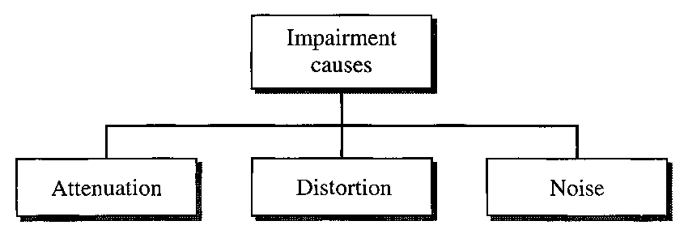

Attenuation

Attenuation means a loss of energy. When a signal, simple or composite, travels through a medium, it loses some of its energy in overcoming the resistance of the medium. That is why a wire carrying electric signals gets warm, if not hot, after a while. Some of the electrical energy in the signal is converted to heat. To compensate for this loss, amplifiers are used to amplify the signal.

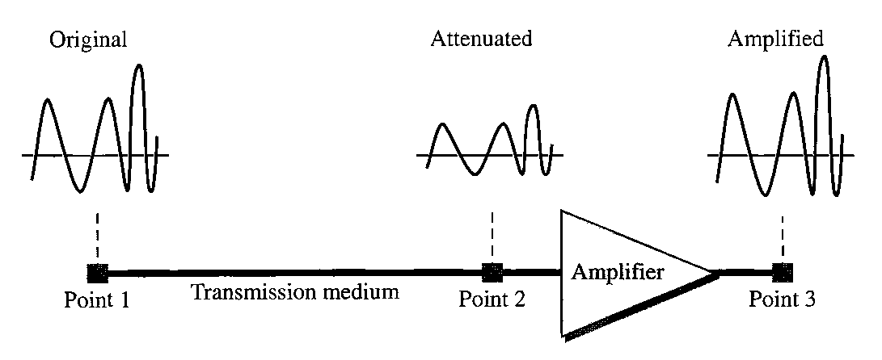

Decibel

To show that a signal has lost or gained strength, engineers use the unit of the decibel. The decibel (dB) measures the relative strengths of two signals or one signal at two different points. Note that the decibel is negative if a signal is attenuated and positive if a signal is amplified.
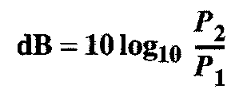
Variables P₁ and P₂ are the powers of a signal at points 1 and 2, respectively.

Distortion

Distortion means that the signal changes its form or shape. Distortion can occur in a composite signal made of different frequencies. Each signal component has its own propagation speed (see the next section) through a medium and, therefore, its own delay in arriving at the final destination. Differences in delay may create a difference in phase if the delay is not exactly the same as the period duration. In other words, signal components at the receiver have phases different from what they had at the sender. The shape of the composite signal is therefore not the same.
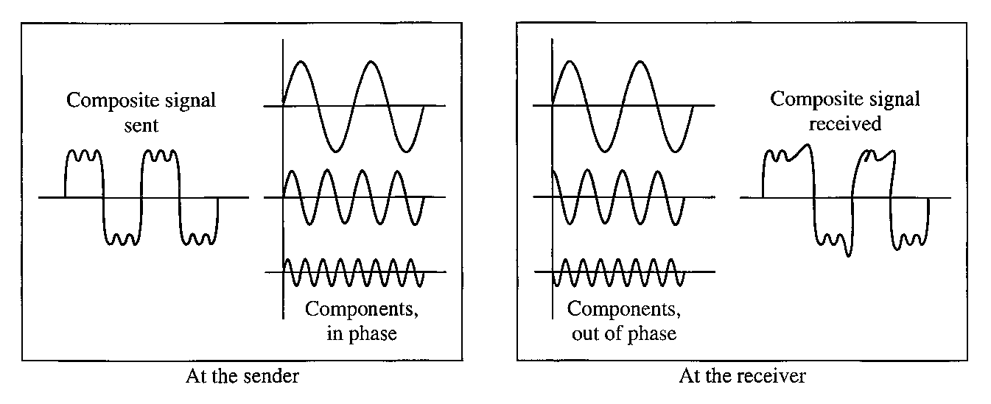
Noise

Noise is another cause of impairment. Several types of noise, such as thermal noise, induced noise, crosstalk, and impulse noise, may corrupt the signal. Thermal noise is the random motion of electrons in a wire which creates an extra signal not originally sent by the transmitter. Induced noise comes from sources such as motors and appliances. These devices act as a sending antenna, and the transmission medium acts as the receiving antenna. Crosstalk is the effect of one wire on the other. One wire acts as a sending antenna and the other as the receiving antenna. Impulse noise is a spike (a signal with high energy in a very short time) that comes from power lines, lightning, and so on.

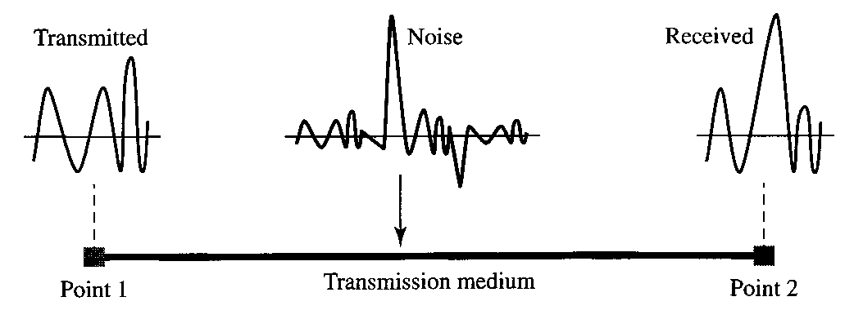

Signal-to-Noise Ratio (SNR)

To find the theoretical bit rate limit, we need to know the ratio of the signal power to the noise power. The signal-to-noise ratio is defined as
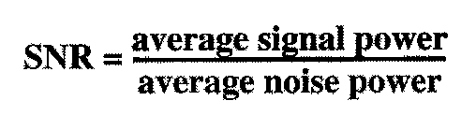
SNR is actually the ratio of what is wanted (signal) to what is not wanted (noise). A high SNR means the signal is less corrupted by noise; a low SNR means the signal is more corrupted by noise.

Because SNR is the ratio of two powers, it is often described in decibel units, SNR_{dB}, defined as


3.3 DATA RATE LIMITS

Data rate depends on three factors:

- The bandwidth available
- The level of the signals we use
- The quality of the channel (the level of noise)

Two theoretical formulas were developed to calculate the data rate: one by Nyquist for
a noiseless channel, another by Shannon for a noisy channel.

Noiseless Channel: Nyquist Bit Rate

For a noiseless channel, the Nyquist bit rate formula defines the theoretical maximum bit rate

BitRate = 2 x bandwidth x log₂L

In this formula, bandwidth is the bandwidth of the channel, L is the number of signal levels used to represent data, and BitRate is the bit rate in bits per second.

According to the formula, we might think that, given a specific bandwidth, we can have any bit rate we want by increasing the number of signal levels. Although the idea is theoretically correct, practically there is a limit. When we increase the number of signal levels, we impose a burden on the receiver. If the number of levels in a signal is just 2, the receiver can easily distinguish between a 0 and a 1. If the level of a signal is 64, the receiver must be very sophisticated to distinguish between 64 different levels. In other words, increasing the levels of a signal reduces the reliability of the system.

Noisy Channel: Shannon Capacity

In reality, we cannot have a noiseless channel; the channel is always noisy. In 1944, Claude Shannon introduced a formula, called the Shannon capacity, to determine the theoretical highest data rate for a noisy channel:

Capacity = bandwidth x log₂(1+SNR)

In this formula, bandwidth is the bandwidth of the channel, SNR is the signal-to-noise ratio, and capacity is the capacity of the channel in bits per second. Note that in the Shannon formula there is no indication of the signal level, which means that no matter how many levels we have, we cannot achieve a data rate higher than the capacity of the channel. In other words, the formula defines a characteristic of the channel, not the method of transmission.

  - PERFORMANCE

Bandwidth

One characteristic that measures network performance is bandwidth. However, the term can be used in two different contexts with two different measuring values: bandwidth in hertz and bandwidth in bits per second.

Bandwidth in Hertz

Bandwidth in hertz is the range of frequencies contained in a composite signal or the range of frequencies a channel can pass. For example, we can say the bandwidth of a subscriber telephone line is 4 kHz.

Bandwidth in Bits per Seconds

The term bandwidth can also refer to the number of bits per second that a channel, a link, or even a network can transmit. For example, one can say the bandwidth of a Fast Ethernet network (or the links in this network) is a maximum of 100 Mbps. This means that this network can send 100 Mbps.

Relationship

There is an explicit relationship between the bandwidth in hertz and bandwidth in bits per seconds. Basically, an increase in bandwidth in hertz means an increase in bandwidth in bits per second. The relationship depends on whether we have baseband transmission or transmission with modulation.

Throughput

The throughput is a measure of how fast we can actually send data through a network. Although, at first glance, bandwidth in bits per second and throughput seem the same, they are different. A link may have a bandwidth of B bps, but we can only send T bps through this link with T always less than B. In other words, the bandwidth is a potential measurement of a link; the throughput is an actual measurement of how fast we can send data. For example, we may have a link with a bandwidth of 1 Mbps, but the devices connected to the end of the link may handle only 200 kbps. This means that we cannot send more than 200 kbps through this link.

Latency (Delay)

The latency or delay defines how long it takes for an entire message to completely arrive at the destination from the time the first bit is sent out from the source. We can say that latency is made of four components: propagation time, transmission time, queuing time and processing delay.
Latency = propagation time + transmission time + queuing time + processing delay

Propagation Time

Propagation time measures the time required for a bit to travel from the source to the destination. The propagation time is calculated by dividing the distance by the propagation speed.
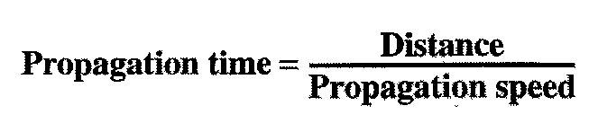
The propagation speed of electromagnetic signals depends on the medium and on the frequency of the signal.

Transmission Time

In data communications we don't send just 1 bit, we send a message. The first bit may take a time equal to the propagation time to reach its destination; the last bit also may take the same amount of time. However, there is a time between the first bit leaving the sender and the last bit arriving at the receiver. The first bit leaves earlier and arrives earlier; the last bit leaves later and arrives later. The time required for transmission of a message depends on the size of the message and the bandwidth of the channel.

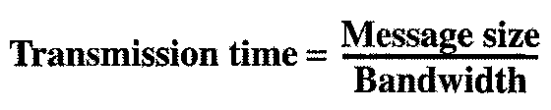

Queuing Time

The third component in latency is the queuing time, the time needed for each intermediate or end device to hold the message before it can be processed. The queuing time is not a fixed factor; it changes with the load imposed on the network. When there is heavy traffic on the network, the queuing time increases. An intermediate device, such as a router, queues the arrived messages and processes them one by one. If there are many messages, each message will have to wait.

Bandwidth-Delay Product

Bandwidth and delay are two performance metrics of a link. What is very important in data communications is the product of the two, the bandwidth-delay product. Let us elaborate on this issue, using two hypothetical cases as examples.

Case 1. The following figure shows case 1.

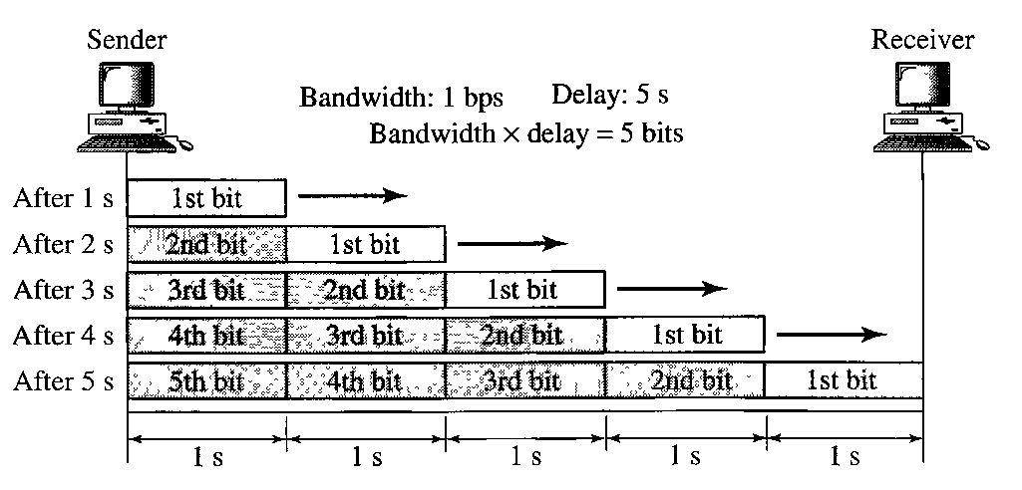

Let us assume that we have a link with a bandwidth of 1 bps Also assume that the delay of the link is 5 s We want to see what the bandwidth-delay product means in this case. From the figure, it can be said that this product 1 x 5 is the maximum number of bits that can fill the link. There can be no more than 5 bits at any time on the link.
Case 2. Now assume we have a bandwidth of 4 bps. The figure shows that there can be maximum 4 x 5 = 20 bits on the line. The reason is that, at each second, there are 4 bits on the line; the duration of each bit is 0.25s.

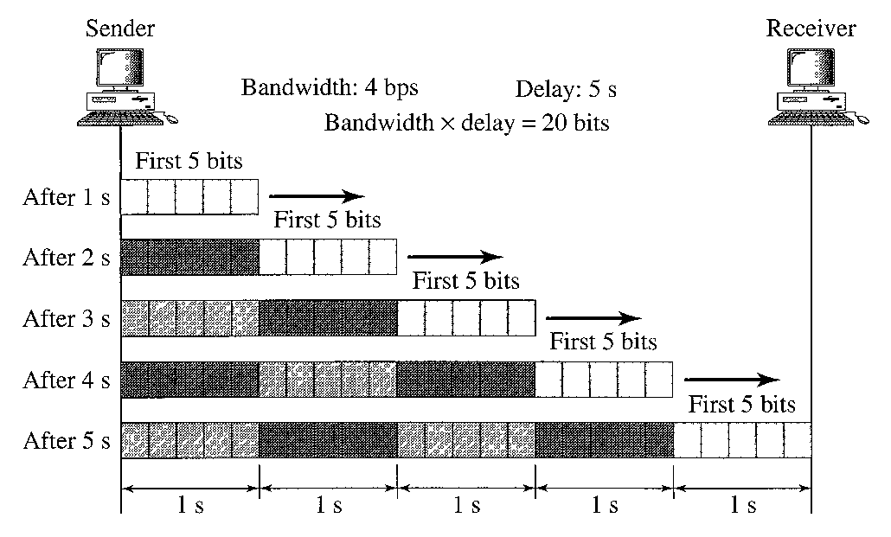

The above two cases show that the product of bandwidth and delay is the number of bits that can fill the link. This measurement is important if we need to send data in bursts and wait for the acknowledgment of each burst before sending the next one. To use the maximum capability of the link, we need to make the size of our burst 2 times the product of bandwidth and delay; we need to fill up the full-duplex channel (two directions). The sender should send a burst of data of (2 x bandwidth x delay) bits. The sender then waits for receiver acknowledgment for part of the burst before sending another burst. The amount 2 x bandwidth x delay is the number of bits that can be in transition at any time.

Jitter

Another performance issue that is related to delay is jitter. We can roughly say that jitter is a problem if different packets of data encounter different delays and the application using the data at the receiver site is time-sensitive (audio and video data, for example). If the delay for the first packet is 20 ms, for the second is 45 ms, and for the third is 40 ms, then the real-time application that uses the packets endures jitter.
Digital Transmission

4.1 DIGITAL-TO-DIGITAL CONVERSION

4.1.1 Line Coding

Line coding is the process of converting digital data to digital signals. We assume that data, in the form of text, numbers, graphical images, audio, or video, are stored in computer memory as sequences of bits. Line coding converts a sequence of bits to a digital signal. At the sender, digital data are encoded into a digital signal; at the receiver, the digital data are recreated by decoding the digital signal.
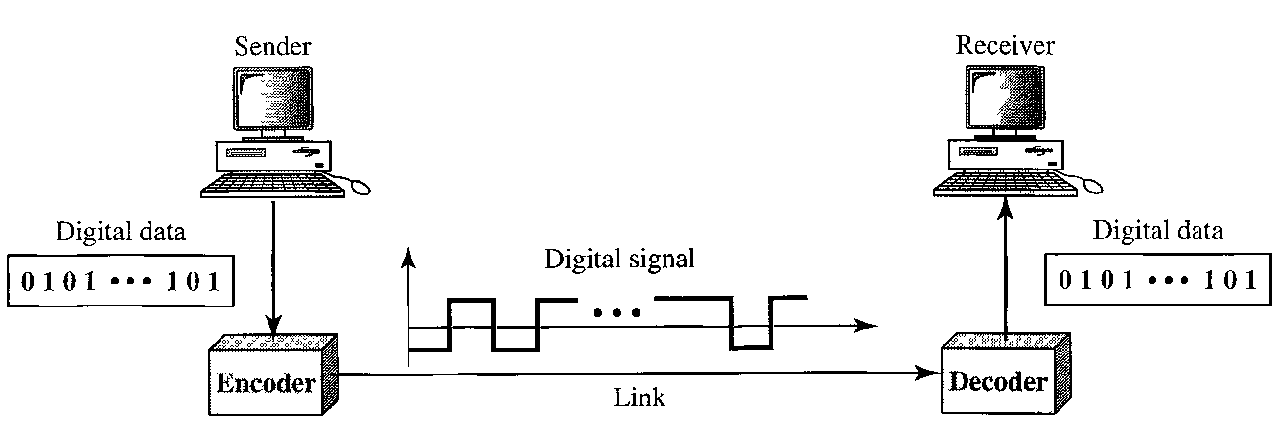

Characteristics

The following are the common characteristics:

Signal Element Versus Data Element Let us distinguish between a data element and a signal element. In data communications, our goal is to send data elements. A data element is the smallest entity that can represent a piece of information: this is the bit. In digital data communications, a signal element carries data elements. A signal element is the shortest unit (timewise) of a digital signal. In other words, data elements are what we need to send; signal elements are what we can send. Data elements are being carried; signal elements are the carriers. We define a ratio r which is the number of data elements carried by each signal element. The following figure shows several situations with different values of r.

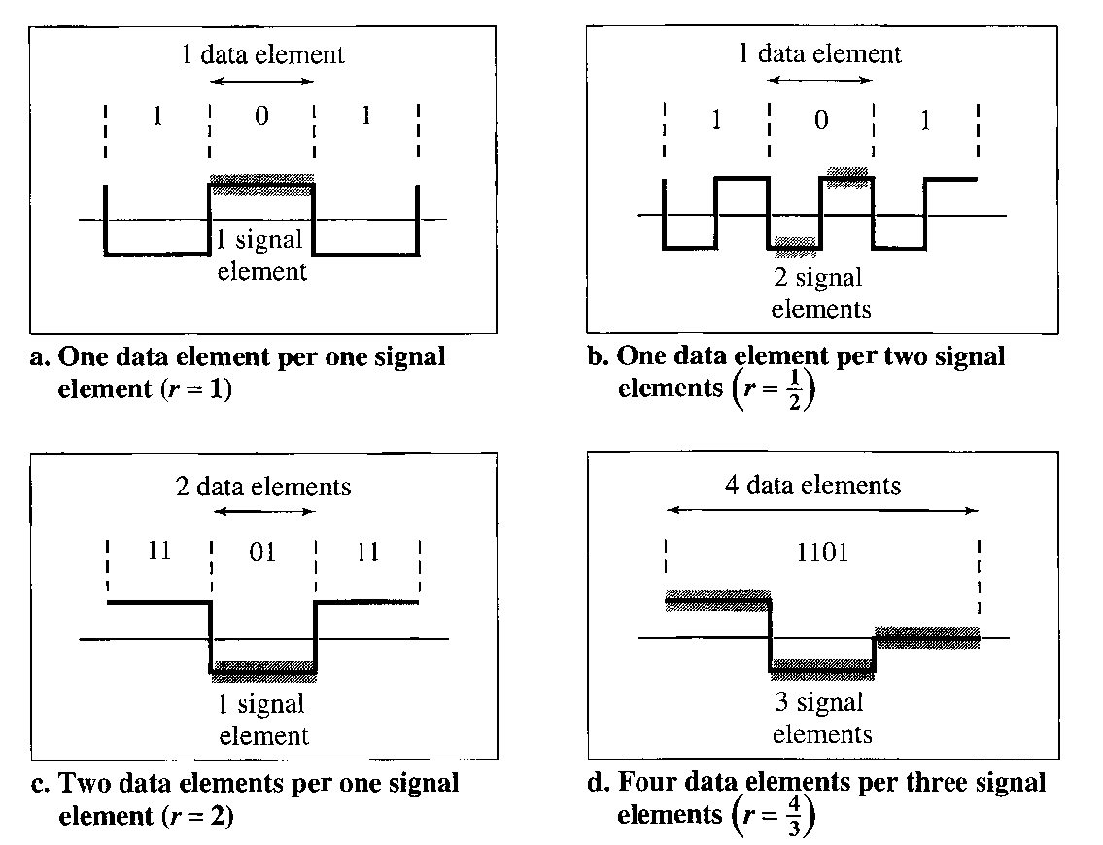

Data Rate Versus Signal Rate The data rate defines the number of data elements (bits) sent in is. The unit is bits per second (bps). The signal rate is the number of signal elements sent in Is. The unit is the baud. There are several common terminologies used in the literature. The data rate is sometimes called the bit rate; the signal rate is sometimes called the pulse rate, the modulation rate, or the baud rate.
One goal in data communications is to increase the data rate while decreasing the signal rate. Increasing the data rate increases the speed of transmission; decreasing the signal rate decreases the bandwidth requirement.
Consider the relationship between data rate and signal rate (bit rate and baud rate). This relationship, of course, depends on the value of r. It also depends on the data pattern. If we have a data pattern of all 1 s or all Os, the signal rate may be different from a data pattern of alternating Os and 1 s. To derive a formula for the relationship, we need to define three cases: the worst, best, and average. The worst case is when we need the maximum signal rate; the best case is when we need the minimum. In data communications, we are usually interested in the average case. We can formulate the relationship between data rate and signal rate as
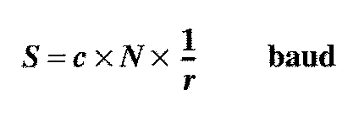
where N is the data rate (bps); c is the case factor, which varies for each case; S is the number of signal elements; and r is the previously defined factor.

Bandwidth A digital signal that carries information is nonperiodic. We also showed that the bandwidth of a nonperiodic signal is continuous with an infinite range. However, most digital signals we encounter in real life have a bandwidth with finite values. In other words, the bandwidth is theoretically infinite, but many of the components have such a small amplitude that they can be ignored. The effective bandwidth is finite.
We can say that the baud rate, not the bit rate, determines the required bandwidth for a digital signal. More changes in the signal mean injecting more frequencies into the signal. (Frequency means change and change means frequency.) The bandwidth reflects the range of frequencies we need. There is a relationship between the baud rate (signal rate) and the bandwidth. The bandwidth (range of frequencies) is proportional to the signal rate (baud rate). The minimum bandwidth can be given as
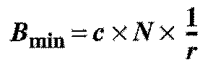
We can solve for the maximum data rate if the bandwidth of the channel is given.

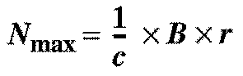

Baseline Wandering In decoding a digital signal, the receiver calculates a running average of the received signal power. This average is called the baseline. The incoming signal power is evaluated against this baseline to determine the value of the data element. A long string of Os or 1 s can cause a drift in the baseline (baseline wandering) and make it difficult for the receiver to decode correctly. A good line coding scheme needs to prevent baseline wandering.

DC Components When the voltage level in a digital signal is constant for a while, the spectrum creates very low frequencies (results of Fourier analysis). These frequencies around zero, called DC (direct-current) components, present problems for a system that cannot pass low frequencies or a system that uses electrical coupling (via a transformer). For example, a telephone line cannot pass frequencies below 200 Hz. Also a long-distance link may use one or more transformers to isolate different parts of the line electrically. For these systems, we need a scheme with no DC component.

Self-synchronization To correctly interpret the signals received from the sender, the receiver's bit intervals must correspond exactly to the sender's bit intervals. If the receiver clock is faster or slower, the bit intervals are not matched and the receiver might misinterpret the signals. The figure shows a situation in which the receiver has a shorter bit duration. The sender sends 10110001, while the receiver receives 110111000011.

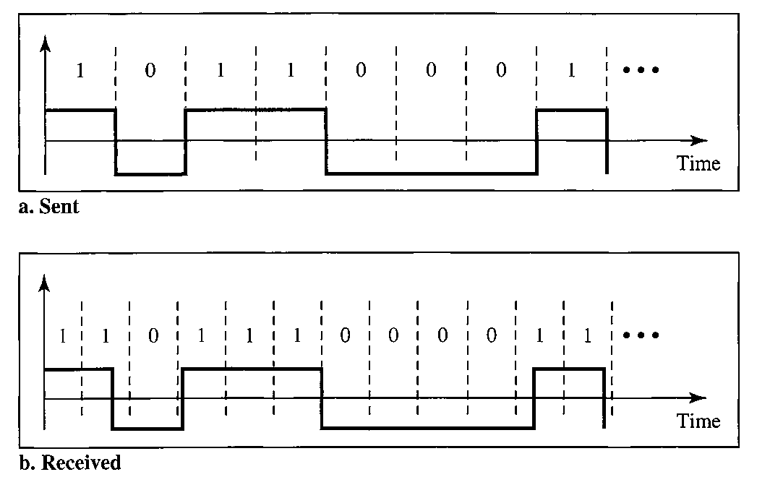

A self-synchronizing digital signal includes timing information in the data being transmitted. This can be achieved if there are transitions in the signal that alert the receiver to the beginning, middle, or end of the pulse. If the receiver' s clock is out of synchronization, these points can reset the clock.

Built-in Error Detection It is desirable to have a built-in error-detecting capability in the generated code to detect some of or all the errors that occurred during transmission. Some encoding schemes that we will discuss have this capability to some extent.

Immunity to Noise and Interference Another desirable code characteristic is a code that is immune to noise and other interferences. Some encoding schemes that we will discuss have this capability.

Complexity A complex scheme is more costly to implement than a simple one. For example, a scheme that uses four signal levels is more difficult to interpret than one that uses only two levels.

Line Coding Schemes

We can roughly divide line coding schemes into five broad categories, as shown:

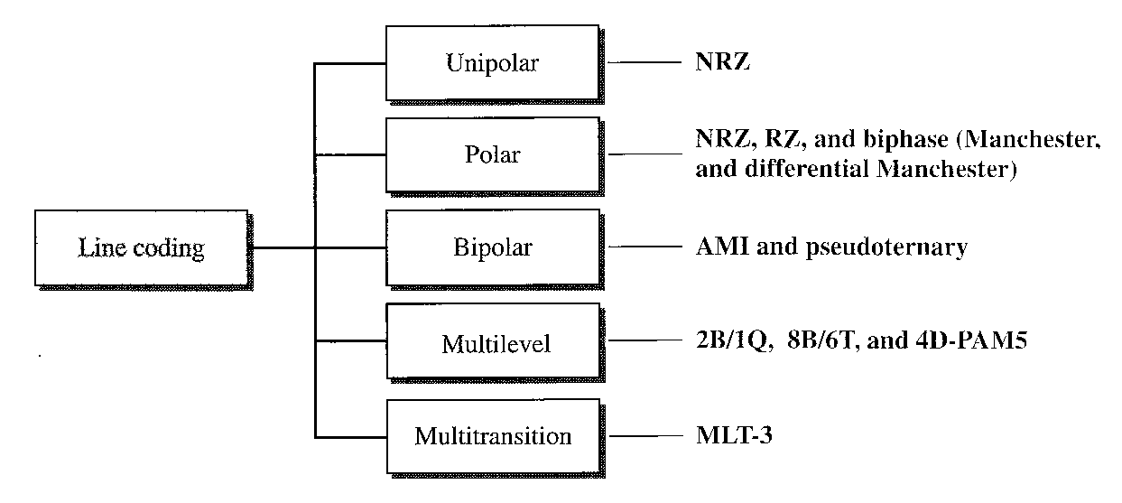

1. Unipolar Scheme

In a unipolar scheme, all the signal levels are on one side of the time axis, either above or below.

NRZ (Non-Return-to-Zero) Traditionally, a unipolar scheme was designed as a non-return-to-zero (NRZ) scheme in which the positive voltage defines bit 1 and the zero voltage defines bit 0. It is called NRZ because the signal does not return to zero at the middle of the bit. The following figure show a unipolar NRZ scheme.
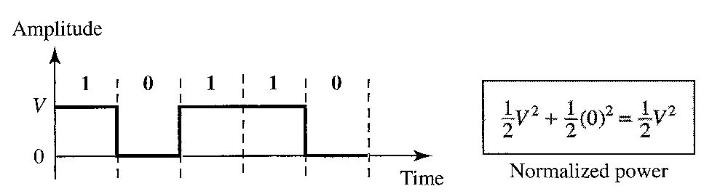

2. Polar Schemes

In polar schemes, the voltages are on the both sides of the time axis. For example, the voltage level for 0 can be positive and the voltage level for 1 can be negative.

Non-Return-to-Zero (NRZ) In polar NRZ encoding, we use two levels of voltage amplitude. We can have two versions of polar NRZ: NRZ-L and NRZ-I, as shown in the figure. The figure also shows the value of r, the average baud rate, and the bandwidth. In the first variation, NRZ-L (NRZ-Level), the level of the voltage determines the value of the bit. In the second variation, NRZ-I (NRZ-Invert), the change or lack of change in the level of the voltage determines the value of the bit. If there is no change, the bit is 0; if there is a change, the bit is 1.

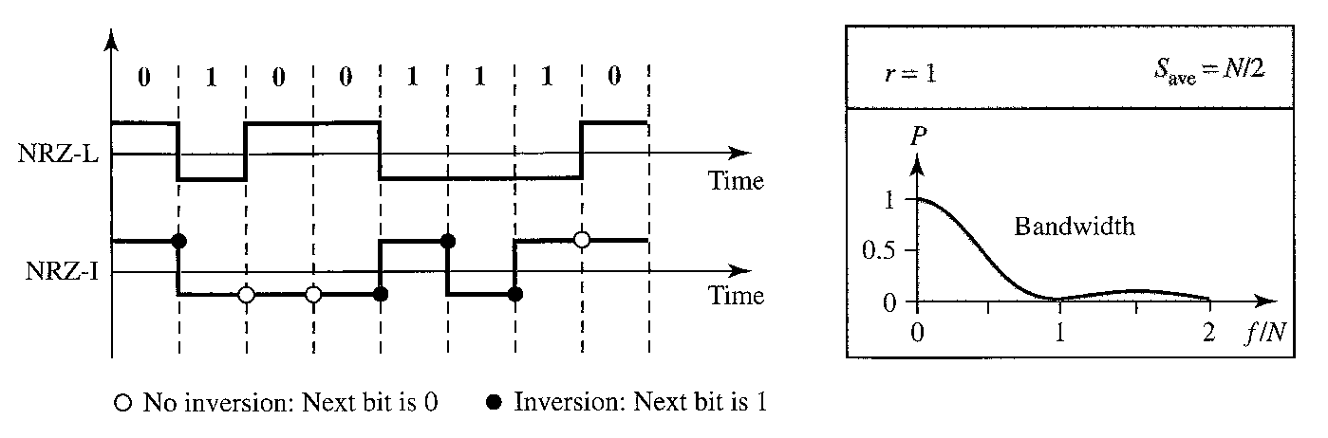

Although baseline wandering is a problem for both variations, it is twice as severe in NRZ-L. If there is a long sequence of 0s or ls in NRZ-L, the average signal power becomes skewed. The receiver might have difficulty discerning the bit value. In NRZ-I this problem occurs only for a long sequence of Os. If somehow we can eliminate the long sequence of 0s, we can avoid baseline wandering.
The synchronization problem (sender and receiver clocks are not synchronized) also exists in both schemes. Again, this problem is more serious in NRZ-L than in NRZ-I. While a long sequence of Os can cause a problem in both schemes, a long sequence of ls affects only NRZ-L.
Another problem with NRZ-L occurs when there is a sudden change of polarity in the system. For example, if twisted-pair cable is the medium, a change in the polarity of the wire results in all Os interpreted as 1 s and all 1 s interpreted as Os. NRZ-I does not have this problem. Both schemes have an average signal rate of N/2 Bd.
The previous figure also shows the normalized bandwidth for both variations. The vertical axis shows the power density (the power for each 1 Hz of bandwidth); the horizontal axis shows the frequency. The bandwidth reveals a very serious problem for this type of encoding. The value of the power density is very high around frequencies close to zero. This means that there are DC components that carry a high level of energy. As a matter of fact, most of the energy is concentrated in frequencies between 0 and N/2. This means that although the average of the signal rate is N/2, the energy is not distributed evenly between the two halves.

Return to Zero (RZ) The main problem with NRZ encoding occurs when the sender and receiver clocks are not synchronized. The receiver does not know when one bit has ended and the next bit is starting. One solution is the return-to-zero (RZ) scheme, which uses three values: positive, negative, and zero. In RZ, the signal changes not between bits but during the bit. In the following figure, we see that the signal goes to 0 in the middle of each bit. It remains there until the beginning of the next bit. The main disadvantage of RZ encoding is that it requires two signal changes to encode a bit and therefore occupies greater bandwidth. The same problem we mentioned, a sudden change of polarity resulting in all Os interpreted as is and all ls interpreted as Os, still exist here, but there is no DC component problem. Another problem is the complexity: RZ uses three levels of voltage, which is more complex to create and discern.

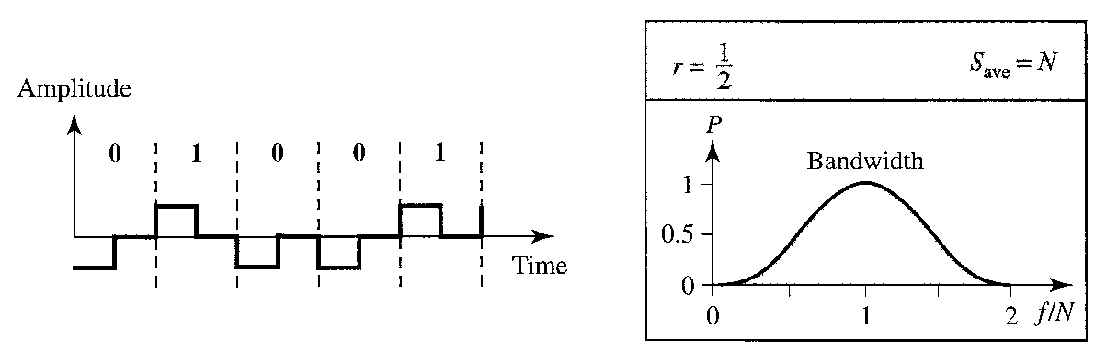

Biphase: Manchester and Differential Manchester The idea of RZ (transition at the middle of the bit) and the idea of NRZ-L are combined into the Manchester scheme. In Manchester encoding, the duration of the bit is divided into two halves. The voltage remains at one level during the first half and moves to the other level in the second half. The transition at the middle of the bit provides synchronization. Differential Manchester, on the other hand, combines the ideas of RZ and NRZ-I. There is always a transition at the middle of the bit, but the bit values are determined at the beginning of the bit. If the next bit is 0, there is a transition; if the next bit is 1, there is none.
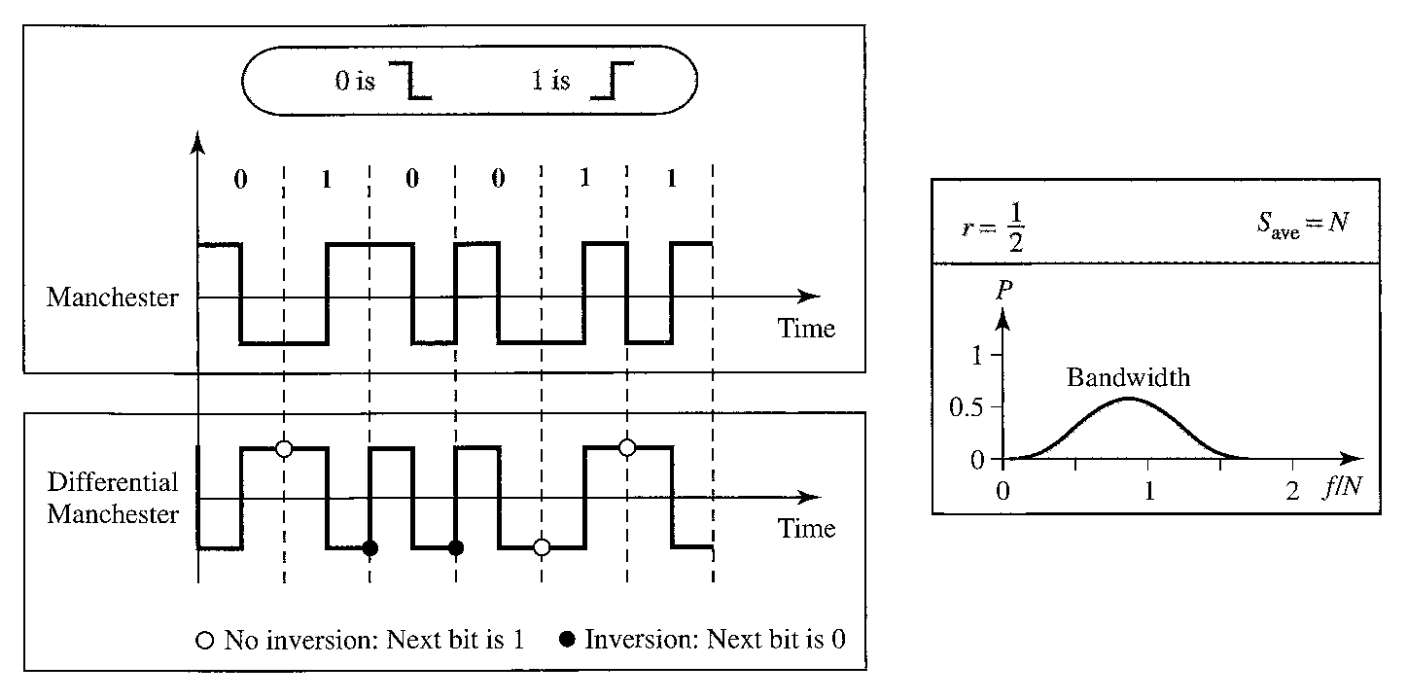
The Manchester scheme overcomes several problems associated with NRZ-L, and differential Manchester overcomes several problems associated with NRZ-I. First, there is no baseline wandering. There is no DC component because each bit has a positive and negative voltage contribution. The only drawback is the signal rate. The signal rate for Manchester and differential Manchester is double that for NRZ. The reason is that there is always one transition at the middle of the bit and maybe one transition at the end of each bit.

3. Bipolar Schemes

In bipolar encoding (sometimes called multilevel binary), there are three voltage levels: positive, negative, and zero. The voltage level for one data element is at zero, while the voltage level for the other element alternates between positive and negative.

AMI and Pseudoternary The figure shows two variations of bipolar encoding: AMI and pseudoternary. A common bipolar encoding scheme is called bipolar alternate mark inversion (AMI). AMI means alternate 1 inversion. A neutral zero voltage represents binary 0. Binary ls are represented by alternating positive and negative voltages. A variation of AMI encoding is called pseudoternary in which the 1 bit is encoded as a zero voltage and the 0 bit is encoded as alternating positive and negative voltages.

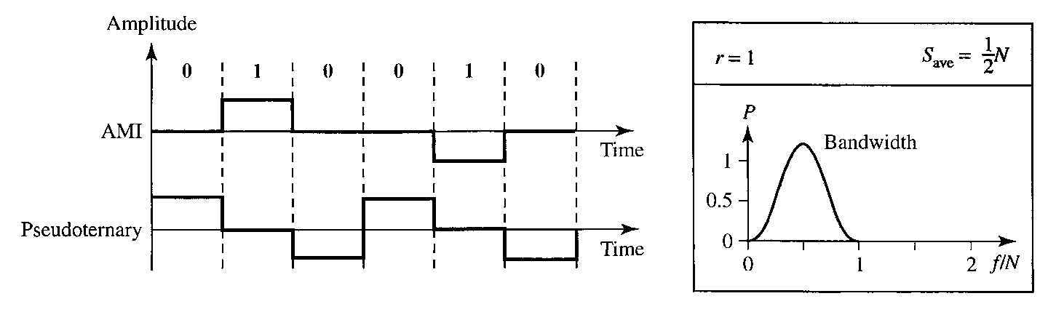

The bipolar scheme was developed as an alternative to NRZ. The bipolar scheme has the same signal rate as NRZ, but there is no DC component. The NRZ scheme has most of its energy concentrated near zero frequency, which makes it unsuitable for transmission over channels with poor performance around this frequency. The concentration of the energy in bipolar encoding is around frequency N/2.
If we have a long sequence of 1 s, the voltage level alternates between positive and negative; it is not constant. Therefore, there is no DC component. For a long sequence of Os, the voltage remains constant, but its amplitude is zero, which is the same as having no DC component. In other words, a sequence that creates a constant zero voltage does not have a DC component.
AMI is commonly used for long-distance communication, but it has a synchronization problem when a long sequence of Os is present in the data.

4.2 ANALOG-TO-DIGITAL CONVERSION

4.2.1 Pulse Code Modulation (PCM)

The most common technique to change an analog signal to digital data (digitization) is called pulse code modulation (PCM). A PCM encoder has three processes, as shown in the figure.

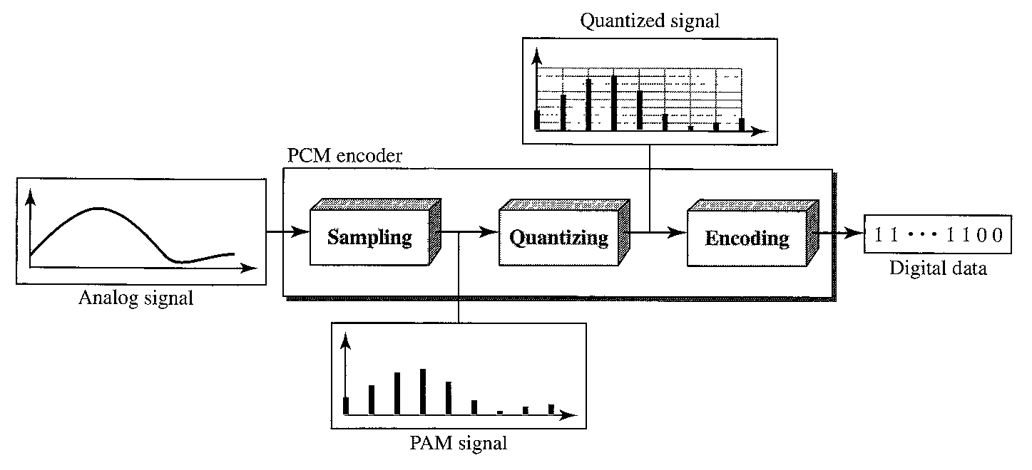
- The analog signal is sampled.
- The sampled signal is quantized.
- The quantized values are encoded as streams of bits.

Sampling

The first step in PCM is sampling. The analog signal is sampled every T_{s} s, where T_{s} is the sample interval or period. The inverse of the sampling interval is called the sampling rate or sampling frequency and denoted by f_{s}, where f_{s} = 1/T_{s}. There are three sampling methods- ideal, natural, and flat-top -as shown below.

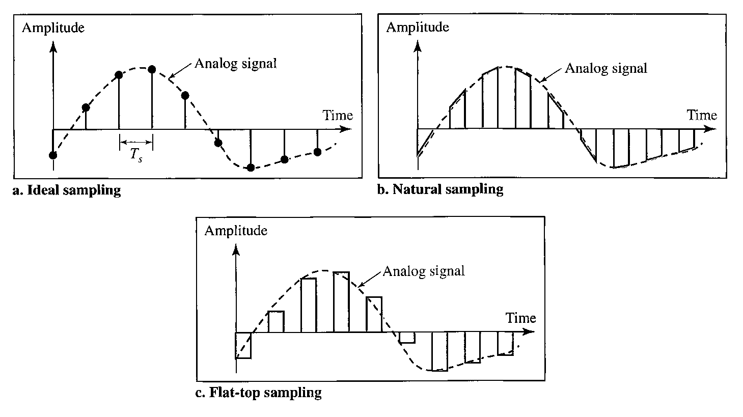

In ideal sampling, pulses from the analog signal are sampled. This is an ideal sampling method and cannot be easily implemented. In natural sampling, a high-speed switch is turned on for only the small period of time when the sampling occurs. The result is a sequence of samples that retains the shape of the analog signal. The most common sampling method, called sample and hold, however, creates flat-top samples by using a circuit. The sampling process is sometimes referred to as pulse amplitude modulation (PAM).

Sampling Rate One important consideration is the sampling rate or frequency. According to the Nyquist theorem, to reproduce the original analog signal, one necessary condition is that the sampling rate be at least twice the highest frequency in the original signal.

First, we can sample a signal only if the signal is band-limited. In other words, a signal with an infinite bandwidth cannot be sampled. Second, the sampling rate must be at least 2 times the highest frequency, not the bandwidth. If the analog signal is low-pass, the bandwidth and the highest frequency are the same value. If the analog signal is bandpass, the bandwidth value is lower than the value of the maximum frequency. The figure shows the value of the sampling rate for two types of signals.

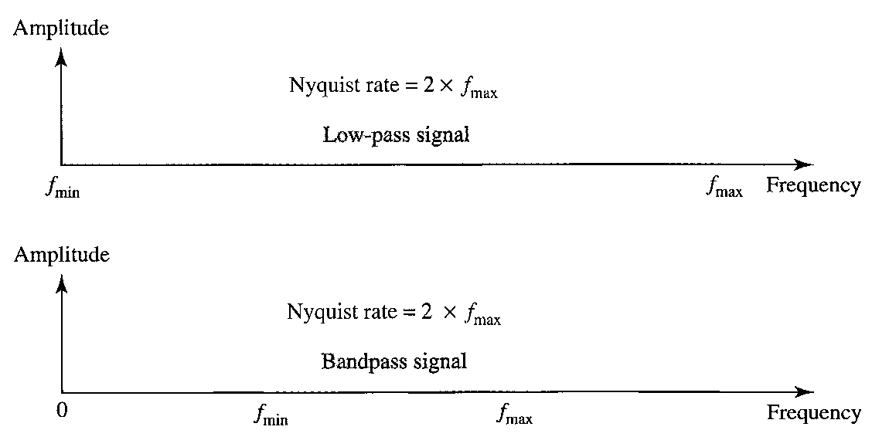

Quantization

The result of sampling is a series of pulses with amplitude values between the maximum and minimum amplitudes of the signal. The set of amplitudes can be infinite with nonintegral values between the two limits. These values cannot be used in the encoding process. The following are the steps in quantization:

- We assume that the original analog signal has instantaneous amplitudes between V_{min} and V_{max}.

- We divide the range into L zones, each of height Δ(delta).
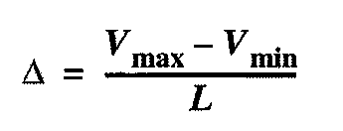
- We assign quantized values of 0 to L - 1 to the midpoint of each zone.
- We approximate the value of the sample amplitude to the quantized values.

As a simple example, assume that we have a sampled signal and the sample amplitudes are between -20 and +20 V. We decide to have eight levels (L = 8). This means that Δ = 5 V. The figure shows this example.

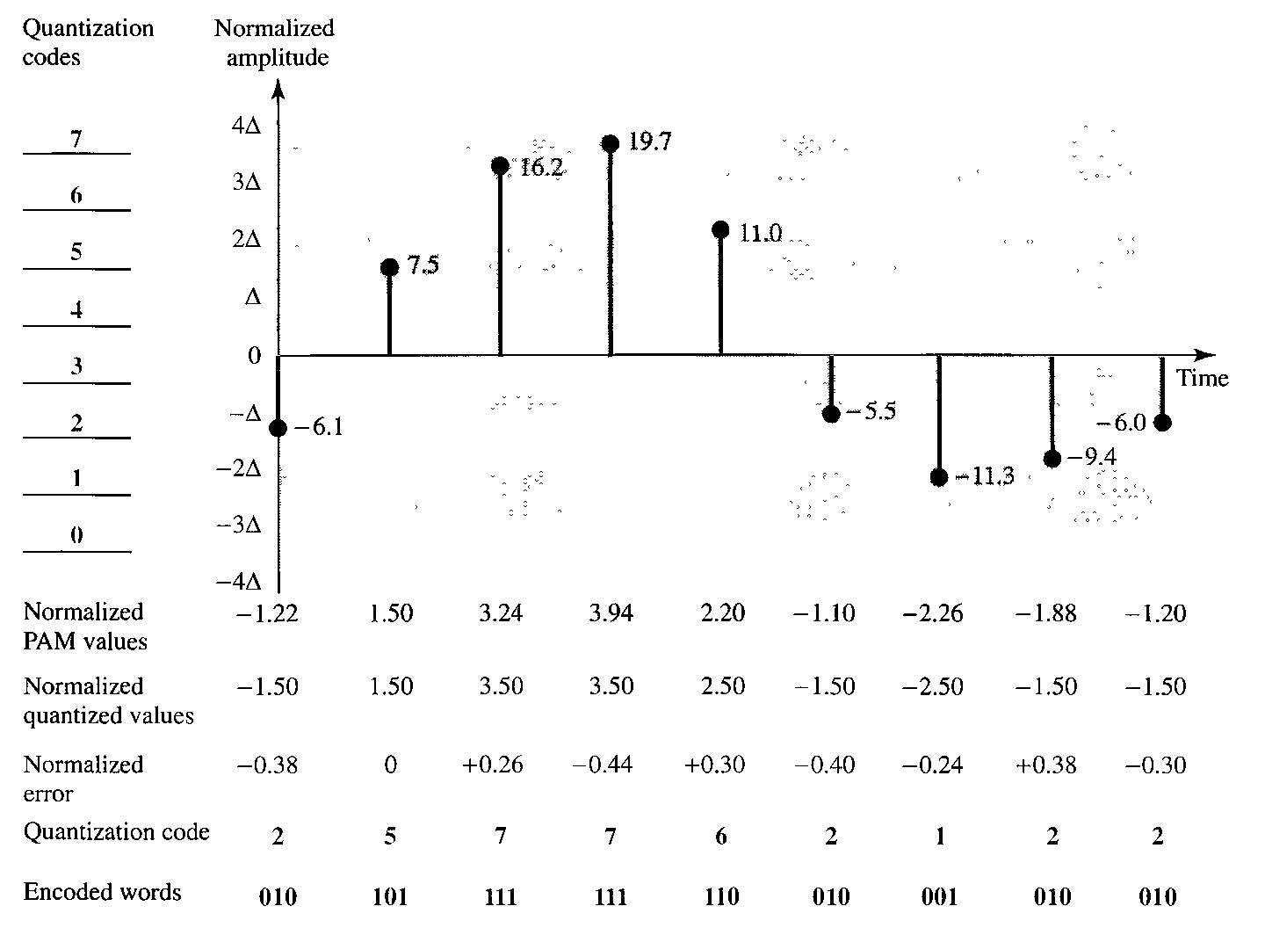

The value at the top of each sample in the graph shows the actual amplitude. In the chart, the first row is the normalized value for each sample (actual amplitude/ Δ). The quantization process selects the quantization value from the middle of each zone. This means that the normalized quantized values (second row) are different from the normalized amplitudes. The difference is called the normalized error (third row). The fourth row is the quantization code for each sample based on the quantization levels at the left of the graph. The encoded words (fifth row) are the final products of the conversion.

Quantization Levels The choice of L, the number of levels, depends on the range of the amplitudes of the analog signal and how accurately we need to recover the signal. If the amplitude of a signal fluctuates between two values only, we need only two levels; if the signal, like voice, has many amplitude values, we need more quantization levels. In audio digitizing, L is normally chosen to be 256; in video it is normally thousands. Choosing lower values of L increases the quantization error if there is a lot of fluctuation in the signal.

Quantization Error Quantization is an approximation process. The input values to the quantizer are the real values; the output values are the approximated values. The output values are chosen to be the middle value in the zone. If the input value is also at the middle of the zone, there is no quantization error; otherwise, there is an error. In the previous example, the normalized amplitude of the third sample is 3.24, but the normalized quantized value is 3.50. This means that there is an error of +0.26. The value of the error for any sample is less than Δ/2. In other words, we have - Δ/2 ≤ error ≤ Δ/2.
The quantization error changes the signal-to-noise ratio of the signal, which in turn reduces the upper limit capacity according to Shannon.

The contribution of the quantization error to the SNR_{dB} of the signal depends on the number of quantization levels L, or the bits per sample n_{b}, as shown in the following formula:


Uniform Versus Non-uniform Quantization For many applications, the distribution of the instantaneous amplitudes in the analog signal is not uniform. Changes in amplitude often occur more frequently in the lower amplitudes than in the higher ones. For these types of applications it is better to use nonuniform zones. In other words, the height of Δ is not fixed; it is greater near the lower amplitudes and less near the higher amplitudes. Nonuniform quantization can also be achieved by using a process called companding and expanding. The signal is companded at the sender before conversion; it is expanded at the receiver after conversion. Companding means reducing the instantaneous voltage amplitude for large values; expanding is the opposite process. Companding gives greater weight to strong signals and less weight to weak ones. It has been proved that nonuniform quantization effectively reduces the SNR_{dB} of quantization.

Encoding

The last step in PCM is encoding. After each sample is quantized and the number of bits per sample is decided, each sample can be changed to an n_{b}-bit code word. A quantization code of 2 is encoded as 010; 5 is encoded as 101; and so on. Note that the number of bits for each sample is determined from the number of quantization levels. If the number of quantization levels is L, the number of bits is n b = log 2 L. The bit rate can be found from the formula:
Bit rate = sampling rate x number of bits per sample = f_{s} x n_{b}

Original Signal Recovery

The recovery of the original signal requires the PCM decoder. The decoder first uses circuitry to convert the code words into a pulse that holds the amplitude until the next pulse. After the staircase signal is completed, it is passed through a low-pass filter to smooth the staircase signal into an analog signal. The filter has the same cut-off frequency as the original signal at the sender. If the signal has been sampled at (or greater than) the Nyquist sampling rate and if there are enough quantization levels, the original signal will be recreated. The maximum and minimum values of the original signal can be achieved by using amplification. The figure shows the simplified process.
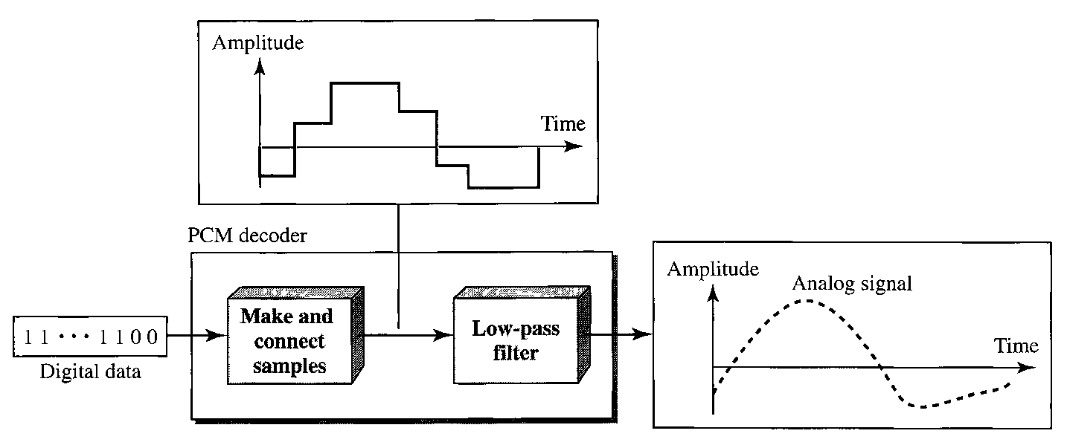

PCM Bandwidth

The minimum bandwidth of a line-encoded signal is B_{min} = c x N x (l/r). We substitute the value of N in this formula:
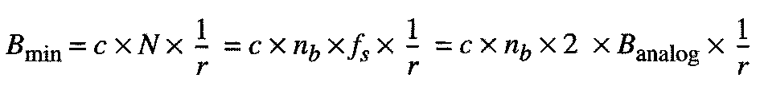
When 1/r = 1 (for a NRZ or bipolar signal) and c = (1/2) (the average situation), the minimum bandwidth is



This means the minimum bandwidth of the digital signal is n_{b} times greater than the bandwidth of the analog signal.

Maximum Data Rate of a Channel

The Nyquist theorem gives the data rate of a channel as N_{max} = 2 x B x log₂L. We can deduce this rate from the Nyquist sampling theorem by using the following arguments.

- We assume that the available channel is low-pass with bandwidth B.
- We assume that the digital signal we want to send has L levels, where each level is a signal element. This means r = 1/log2L.
- We first pass the digital signal through a low-pass filter to cut off the frequencies above B Hz.
- We treat the resulting signal as an analog signal and sample it at 2 x B samples per second and quantize it using L levels. Additional quantization levels are useless because the signal originally had L levels.
- The resulting bit rate is N =f_{s} x n_{b} = 2 x B x log₂L. This is the maximum bandwidth; if the case factor c increases, the data rate is reduced.


Minimum Required Bandwidth

The previous argument can give us the minimum bandwidth if the data rate and the number of signal levels are fixed. We can say
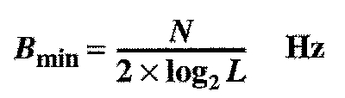

4.3 TRANSMISSION MODES

The transmission of binary data across a link can be accomplished in either parallel or serial mode. In parallel mode, multiple bits are sent with each clock tick. In serial mode, 1 bit is sent with each clock tick. While there is only one way to send parallel data, there are three subclasses of serial transmission: asynchronous, synchronous, and isochronous.
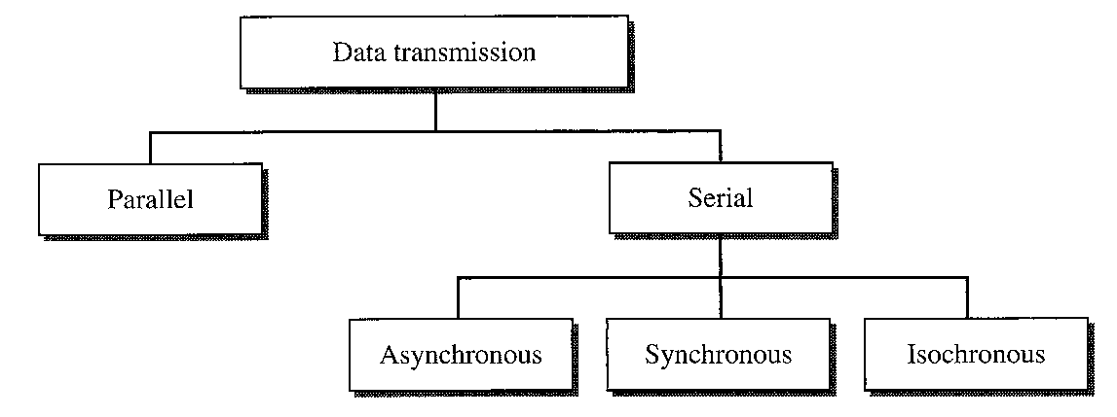
Parallel Transmission

Binary data, consisting of ls and Os, may be organized into groups of n bits each. Computers produce and consume data in groups of bits. By grouping, we can send data n bits at a time instead of 1. This is called parallel transmission.
The mechanism for parallel transmission is a conceptually simple one: Use n wires to send n bits at one time. That way each bit has its own wire, and all n bits of one group can be transmitted with each clock tick from one device to another. The following figure shows how parallel transmission works for n = 8. Typically, the eight wires are bundled in a cable with a connector at each end.
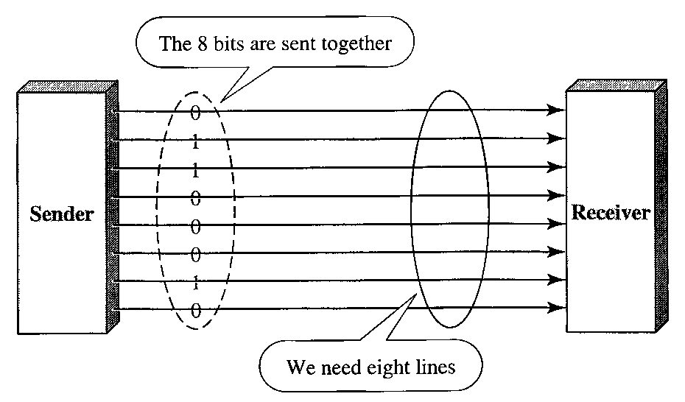

The advantage of parallel transmission is speed. All else being equal, parallel transmission can increase the transfer speed by a factor of n over serial transmission.
But there is a significant disadvantage: cost. Parallel transmission requires n communication lines just to transmit the data stream. Because this is expensive, parallel transmission is usually limited to short distances.

Serial Transmission

In serial transmission one bit follows another, so we need only one communication channel rather than n to transmit data between two communicating devices.

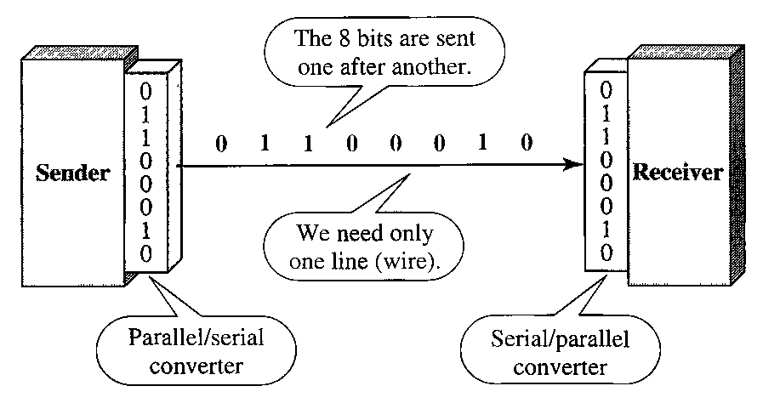

The advantage of serial over parallel transmission is that with only one communication channel, serial transmission reduces the cost of transmission over parallel by roughly a factor of n.
Since communication within devices is parallel, conversion devices are required at the interface between the sender and the line (parallel-to-serial) and between the line and the receiver (serial-to-parallel).
Serial transmission occurs in one of three ways: asynchronous, synchronous, and isochronous.

Asynchronous Transmission

Asynchronous transmission is so named because the timing of a signal is unimportant. Instead, information is received and translated by agreed upon patterns. As long as those patterns are followed, the receiving device can retrieve the information without regard to the rhythm in which it is sent. Patterns are based on grouping the bit stream into bytes. Each group, usually 8 bits, is sent along the link as a unit. The sending system handles each group independently, relaying it to the link whenever ready, without regard to a timer.

Without synchronization, the receiver cannot use timing to predict when the next group will arrive. To alert the receiver to the arrival of a new group, therefore, an extra bit is added to the beginning of each byte. This bit, usually a 0, is called the start bit. To let the receiver know that the byte is finished, 1 or more additional bits are appended to the end of the byte. These bits, usually 1 s, are called stop bits. By this method, each byte is increased in size to at least 10 bits, of which 8 bits is information and 2 bits or more are signals to the receiver. In addition, the transmission of each byte may then be followed by a gap of varying duration. This gap can be represented either by an idle channel or by a stream of additional stop bits.

The start and stop bits and the gap alert the receiver to the beginning and end of each byte and allow it to synchronize with the data stream. This mechanism is called asynchronous because, at the byte level, the sender and receiver do not have to be synchronized. But within each byte, the receiver must still be synchronized with the incoming bit stream. That is, some synchronization is required, but only for the duration of a single byte. The receiving device resynchronizes at the onset of each new byte. When the receiver detects a start bit, it sets a timer and begins counting bits as they come in. After n bits, the receiver looks for a stop bit. As soon as it detects the stop bit, it waits until it detects the next start bit.

The figure is a schematic illustration of asynchronous transmission. In this example, the start bits are 0s, the stop bits are ls, and the gap is represented by an idle line rather than by additional stop bits.

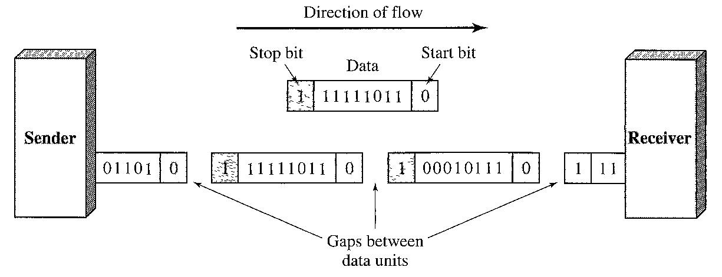

The addition of stop and start bits and the insertion of gaps into the bit stream make asynchronous transmission slower than forms of transmission that can operate without the addition of control information. But it is cheap and effective, two advantages that make it an attractive choice for situations such as low-speed communication.

Synchronous Transmission

In synchronous transmission, the bit stream is combined into longer "frames," which may contain multiple bytes. Each byte, however, is introduced onto the transmission link without a gap between it and the next one. It is left to the receiver to separate the bit stream into bytes for decoding purposes. In other words, data are transmitted as an unbroken string of 1 s and 0s, and the receiver separates that string into the bytes, or characters, it needs to reconstruct the information.

The figure gives a schematic illustration of synchronous transmission. The sender puts its data onto the line as one long string. If the sender wishes to send data in separate bursts, the gaps between bursts must be filled with a special sequence of 0s and ls that means idle. The receiver counts the bits as they arrive and groups them in 8-bit units.

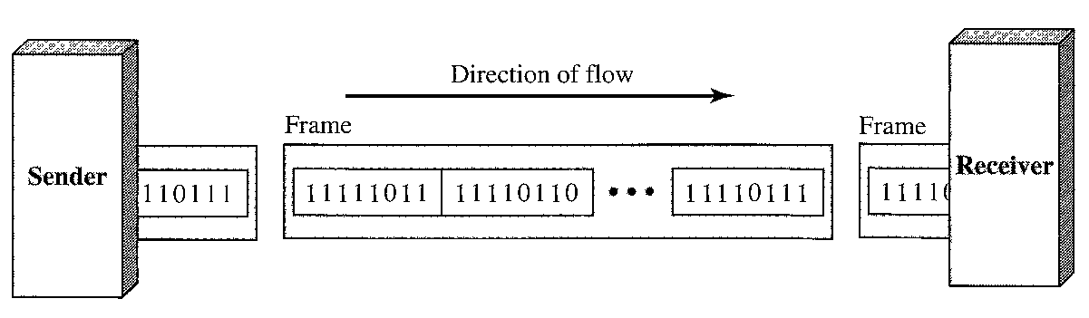

Without gaps and start and stop bits, there is no built-in mechanism to help the receiving device adjust its bit synchronization midstream. Timing becomes very important, therefore, because the accuracy of the received information is completely dependent on the ability of the receiving device to keep an accurate count of the bits as they come in.
The advantage of synchronous transmission is speed. With no extra bits or gaps to introduce at the sending end and remove at the receiving end, and, by extension, with fewer bits to move across the link, synchronous transmission is faster than asynchronous transmission. For this reason, it is more useful for high-speed applications such as the transmission of data from one computer to another.

Isochronous

In real-time audio and video, in which uneven delays between frames are not acceptable, synchronous transmission fails. For example, TV images are broadcast at the rate of 30 images per second; they must be viewed at the same rate. If each image is sent by using one or more flames, there should be no delays between frames. For this type of application, synchronization between characters is not enough; the entire stream of bits must be synchronized. The isochronous transmission guarantees that the data arrive at a fixed rate.

